SSIP2.0 Sensitization Sessions

Event Name: Expert Lecture on Idea Generation

Date: 10-09-2026

Venue/ Mode: Seminar Hall, Government Science College Zalod / Offline

No of Participants: 95

Speakers Name :

Mr. Harendra H. Parmar

About Event:

A Expert Lecture on Idea Generation of SSPI was organized specially for the students at Government Science College Zalod, on 10/09/ 2026.Mr. Harendra H. Parmar (Psychology) From Government Arts and Commerce College Sanjeli .90 Students of our College were present in this lecture.

Outcome of Event:
The lecture made the students to understand what is Idea, and how to generate it

rt-up and Innovation Policy 2.0
Event Photos

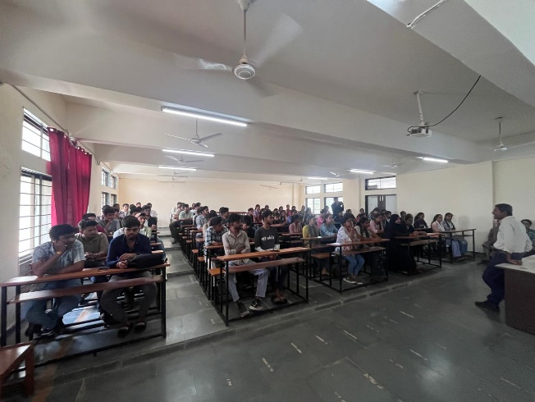
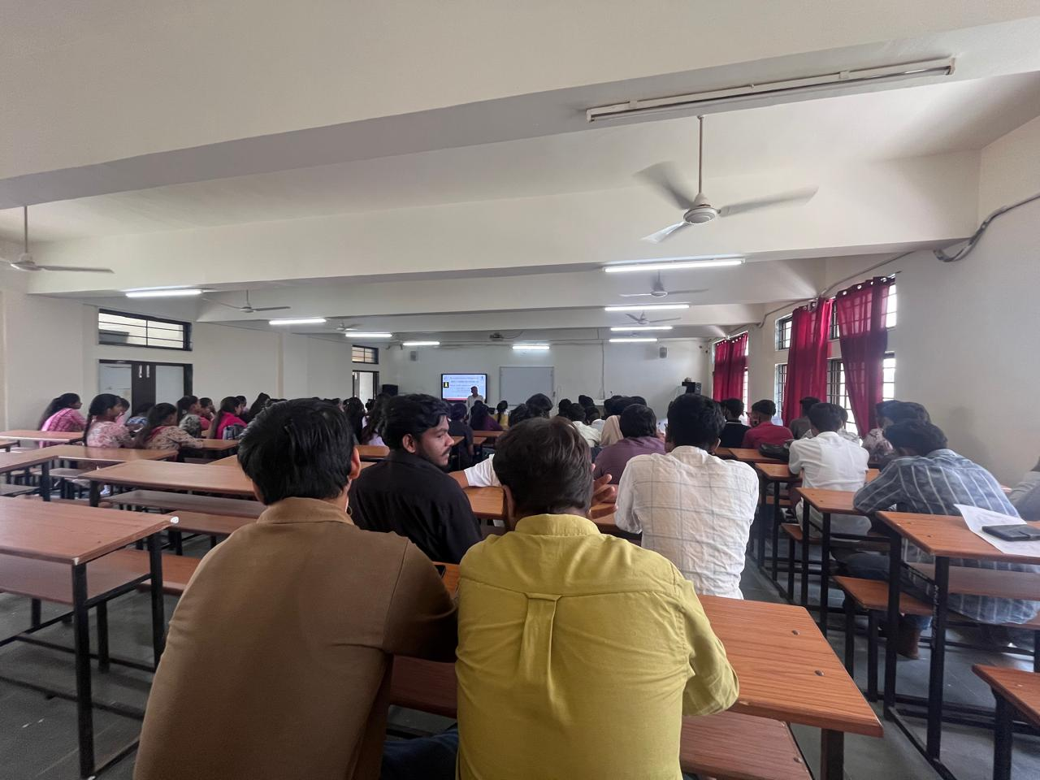

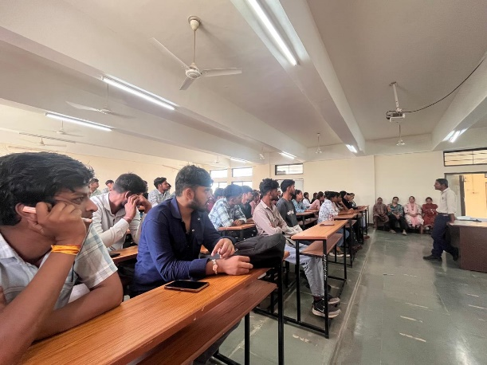
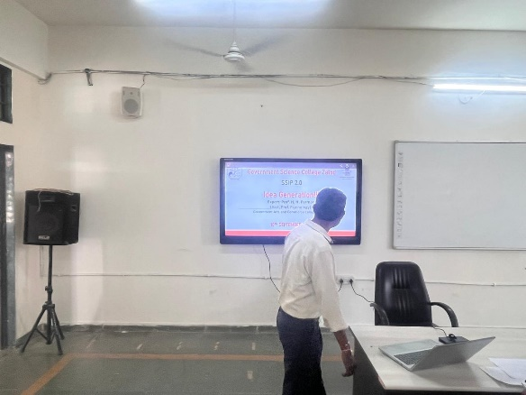

Student Start-up and Innovation Policy 2.0

