WORKSHOP REPORT
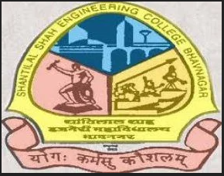 | 

A seminar on 'Idea to Design' was conducted under SSIP 2.0 at Shantilal Shah Engineering College, Bhavnagar on 25th February 2026. The seminar was delivered by Prof. N. P. Soni. The session focused on guiding students through the journey of transforming innovative ideas into practical and effective designs. Students were introduced to the importance of creativity, problem-solving, design thinking, and prototype development in the innovation process.
A total of 150 students actively participated in the event. The seminar inspired students to think innovatively and develop structured approaches for converting concepts into workable solutions.
Event Details
Particular | Details
Event Name | Idea to Design Seminar
Organized Under | SSIP 2.0
Venue | Shantilal Shah Engineering College, Bhavnagar
Date | 25 February 2026
Speaker | Prof. N. P. Soni
Total Participation | 150 Students

Event Photographs
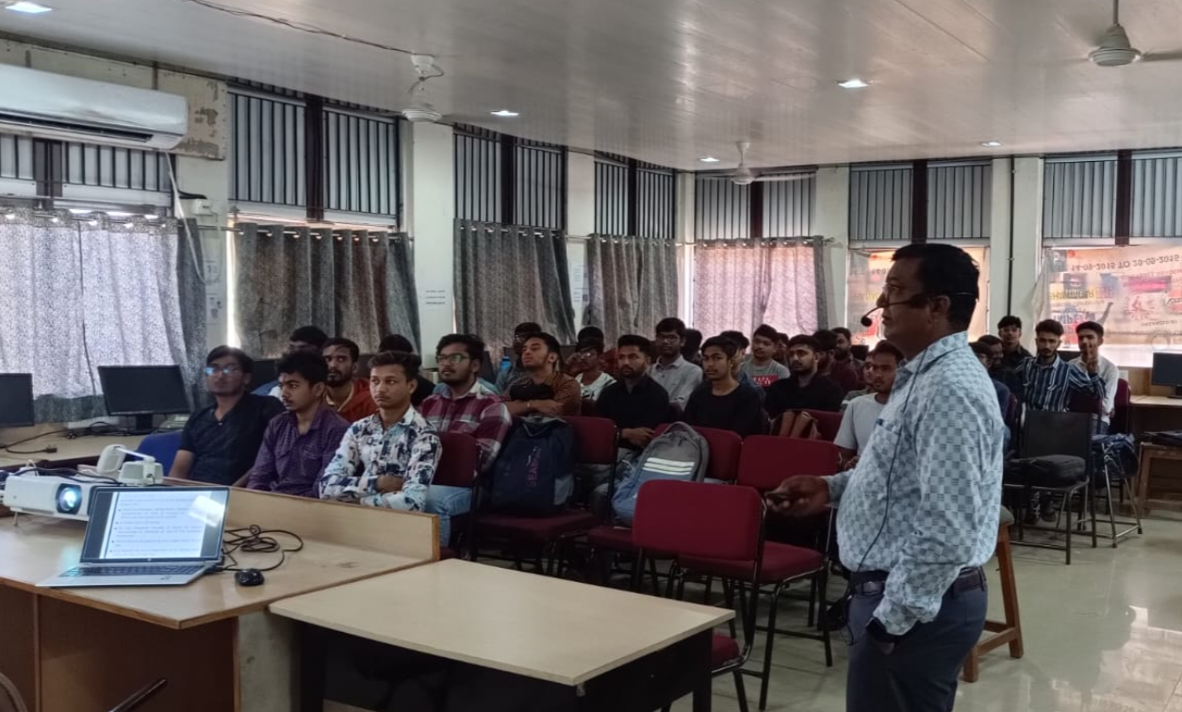
Seminar session conducted under SSIP 2.0.
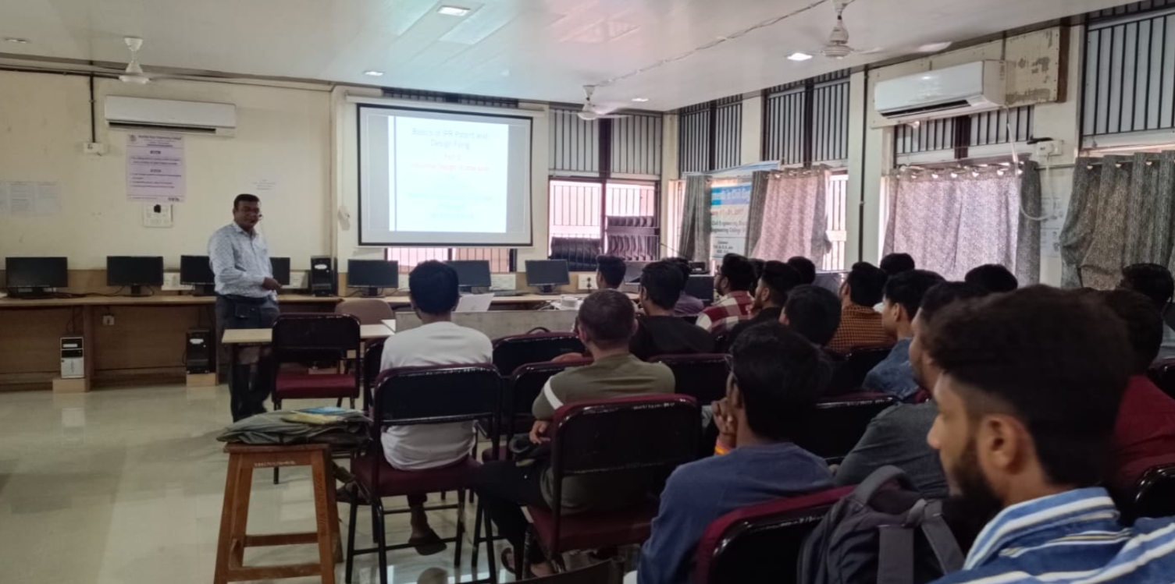
Students participated during the seminar.
The seminar successfully motivated students towards innovation and design thinking, encouraging them to transform creative ideas into impactful engineering solutions.

