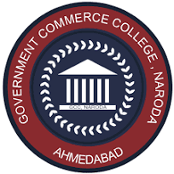
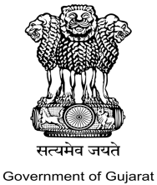
Government Commerce College, Naroda
“B+” NAAC Accredited
Behind Janseva Kendra, Manoharvilla Cross Road,
Nikol Naroda Road, Naroda Ahmedabad -382346 Principal
Ph no: 079-2970-0783 Email- Id:gccnaroda@gmail.com Dr. P.R. Patel

Date: 29/11/25
Report on Workshop: Problem Identification and Idea Generation
Date: 26/11/2025
Venue: Government Commerce College, Naroda
Speaker: Mr. Abhijit Bihola
Total Participants: 17
The SSIP Cell and Innovation Club organised an insightful workshop on Problem Identification and Idea Generation on 26th November 2025 at Government Commerce College, Naroda. The session was conducted by Mr. Abhijit Bihola, an expert known for his practical approach to creativity, innovation, and entrepreneurial thinking.
The workshop aimed to equip students with the ability to recognize real-world problems and convert them into viable, innovative solutions. Mr. Bihola introduced participants to systematic methods of identifying challenges, analyzing root causes, and brainstorming creative ideas using structured frameworks.
A total of 17 participants actively engaged in the session. Through interactive activities, group discussions, and practical exercises, students gained hands-on experience in generating meaningful ideas and refining them into implementable concepts. The resource person also highlighted the role of critical thinking and observation skills in the innovation process.
The workshop concluded with an interactive Q&A session, where students shared their queries and received valuable guidance from the speaker. Overall, the event proved to be highly informative, motivating students to think innovatively and approach problems with a solution-oriented mindset.

SSIP Coordinator: Dr. Dipti Arora

Glimpse of Event

