SHREE SWAMINARAYAN INSTITUTE OF TECHNOLOGY,
BHAT, GANDHINAGAR

A Report
on
Student Start up Research and Innovation Festival
as part of
Azadi ka Amrit Mahotsav

નવ(શોધા)ત્રિ
New Researcher

Dated: 26/09/2022 to 04/10/2022
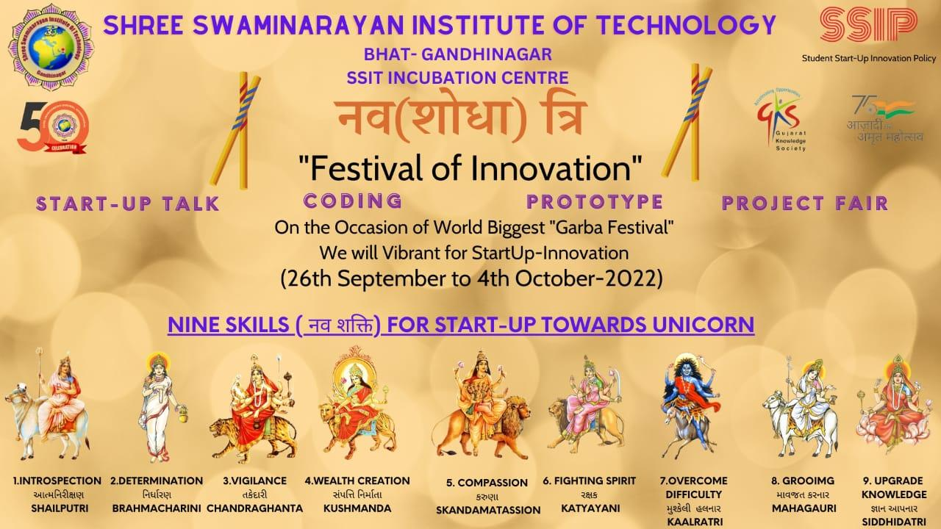

Shree Swaminarayan Institute of Technology, Bhat- Gandhinagar has organized “નવ(શોધા)ત્રિ ( Festival of Innovation)” as part of STUDENT START-UP RESEARCH & INNOVATION FESTIVAL from 26-09-2022 to 04-10-2022 to empower the youth for the Atmanirbhar Bharat.
The Event Event ““નવ(શોધા)ત્રિ ( Festival of Innovation)” means nine days of Navratri is celebrate with Nine Skills. The 9 days of Navratri are dedicated to the worship of 9 forms of the Goddess – Shailaputri, Brahmacharini, Chandraghanta, Kushmanda, Skandamata, Katyayani, Kaalaratri, Mahagauri, Durga or ParaShakti.

The Theme was on the based “Nine Skill for Stat-up Toward the Unicorn”
- Learn Introspection from Goddess Shailputri
- Learn determination from Goddess Brahmacharini
- Learn Vigilance from Goddess Chandraghanta
- Learn wealth creation from Goddess Kushmanda
- Learn compassion from Goddess Skandamata
- Learn the fighting spirit from Goddess Katyayani
- Learn to overcome difficulty from Goddess Kaalratri
- Learn grooming and charisma from Goddess Mahagauri
- Learn to upgrade your knowledge and achie skills from Goddess Siddhidatri

Different Department of SSIT has done number of activity such as Model Presentation, Poster Presentation, Startup talk, Coding, Essay Writing, seminar, Technical Quiz, Web Designing, Hacker Rank etc……

First day : Shailputri- Introspection

HackerRank is a technology platform that is the standard for assessing developer skills for over 2,800+ companies around the world. By enabling tech managers to objectively evaluate talent at every stage of the recruiting process, HackerRank helps companies hire skilled developers and innovate faster. There are 60 participants in this event and 3 problem sum have been given to them on programming languages like c , c++ , Python and Query in SQL.

Winners:
Harsh Lohana (3rd CE)
Smit Patel (3rd IT)

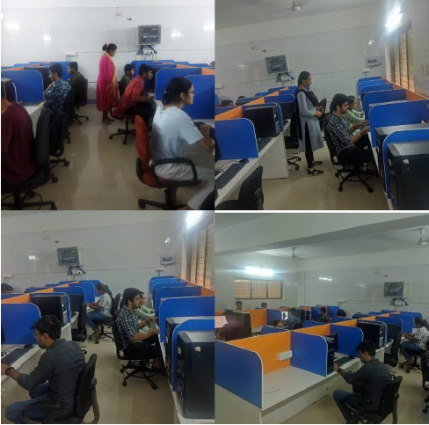

Second day: Mata Brahmacharini- determination

Creating and delivering projects are important elements in business growth and development in a range of industries, including academia, engineering and marketing. A project presentation provides information regarding the project. It should include key details about the project that give enough information to understand the purpose, scope and development of the project. There are 70 participants in this event and projects are on IOT, ML, AI.

Winners:
Thakar Abhishek(7th CE)
Raval Tilak (5th CE)
Chauhan Harsh (5th CE)

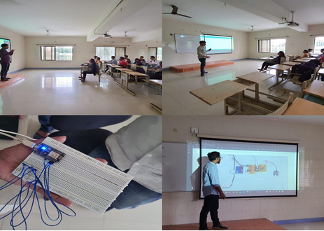

Third day: Mata Chandraghanta-Vigilance
So we have to take care of our Environment and we conducted an Essay writing competition to showcase various reason which destroy our earth due to climate change. The competition was written type where the students showed up their knowledge in the way they see this enthusiastic world and how engineers can contribute it enormously comprising the topic “CLIMATE CHANGE ON EARTH” Overall, 100 students from the first year engineering submitted their essay’s. Considering these responses, the faculty coordinator selected 10 best essays out of 80 by rating them over 6 various parameters- Creativity, Structure, Grammar, Adherence to Topic, Length & Wow-Factor.
Winner
1. Patel karm
2. Dave Bhargavi
3. Vaudehi Thakkar

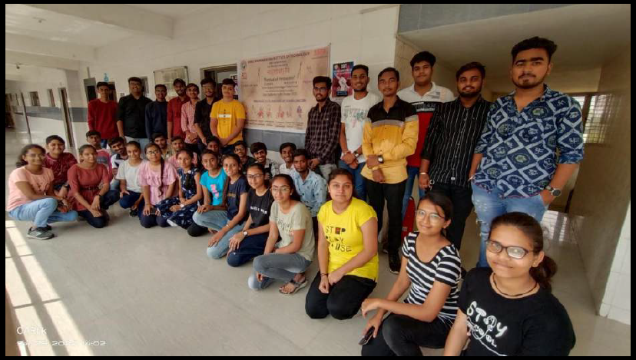 | 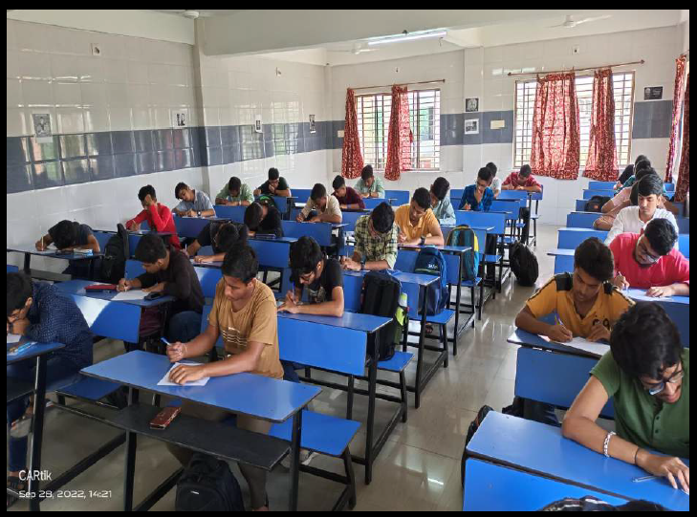
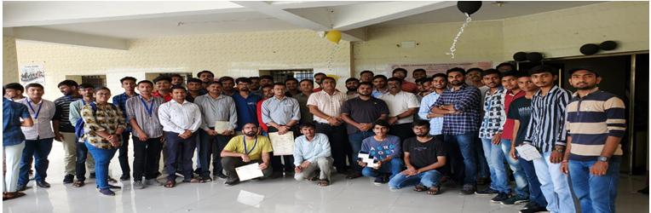

Four and Fifth day :Kushmanda. ,Skandamata -wealth creation and compassion

So as a innovator we should have all skill as mention above. 4 hrs spans was allotted for participants to ready their models. The competition was held at 2nd floor in their classes. Overall, 120 students from the Mechanical Department attended. Further these were judged by Prof. Dharmesh Vandra, Prof. Hitesh Vandra and Prof. Shanjay Sharma. They selected 2 Models as winner team and runners up team. Students enjoy and learn a lot by this model making event

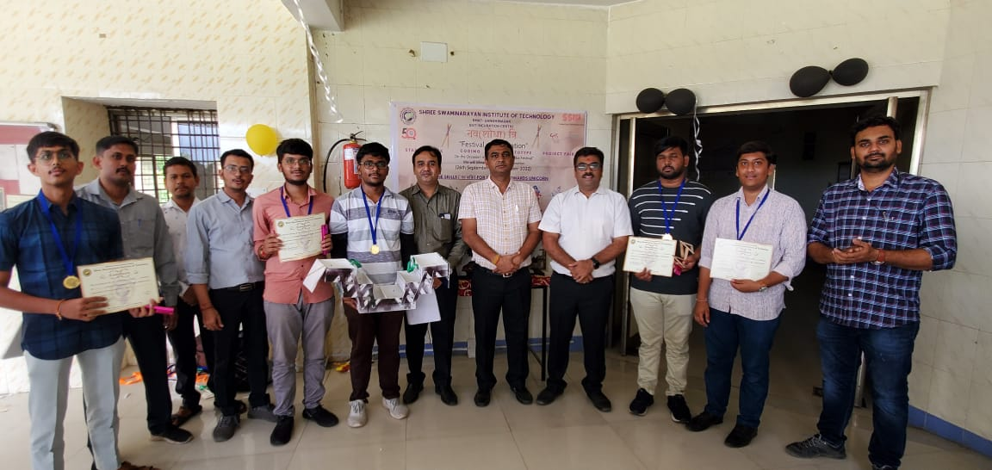
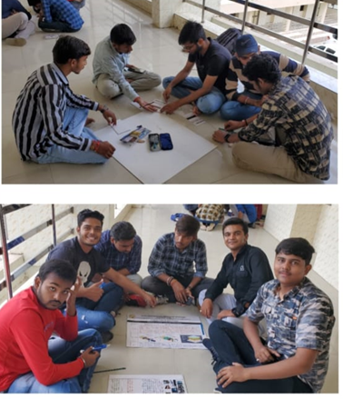 | 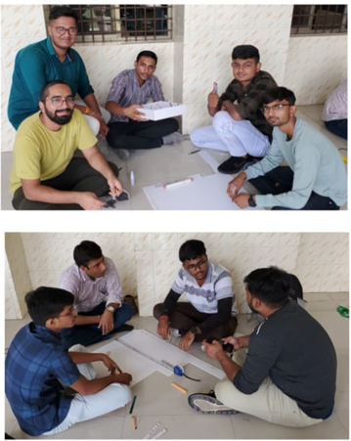

Six, Seven and Eight Day: Mata Katyayani, Kaalratri, Mahagauri -fighting spirit, overcome difficulty, grooming and charisma.
On this day ‘Urban town planning’ competition was organized by the students of civil engineering as an initiative to discover the nine skills in the students, competition was held at Ground floor B-block, 6 groups of total 50+ students from the 2nd and 3rd year engineering participated in this event and the entire group has completed this Prototype model in within the time limit. Considering these responses, the faculty coordinator selected top 2 Prototype model out of 6 groups by rating them over 6 various parameters like idea and concept, town planning criteria and guidelines, Creativity and Structure. Further these were judged by Dr. Hitesh Vandra Sir, Prof. Sanjay Sharma sir and Prof.Dipika shah. They selected 1 winner and first runners up of participants namely:
1. Patel Archita and group (winner)
2. Shah Prit and group 3rd sem civil (first runner’s up)

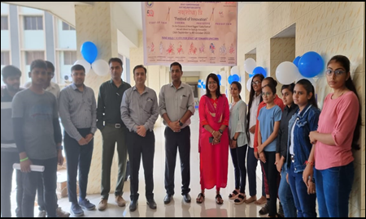 | 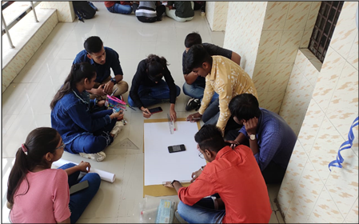
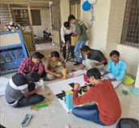 | 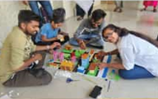

SHREE SWAMINARAYAN INSTITUTE OF TECHNOLOGY,
BHAT, GANDHINAGAR
A Report
on
Student Start up Research and Innovation Festival
as part of
Azadi ka Amrit Mahotsav

નવ(શોધા)ત્રિ
New Researcher

Dated:08/10/2022
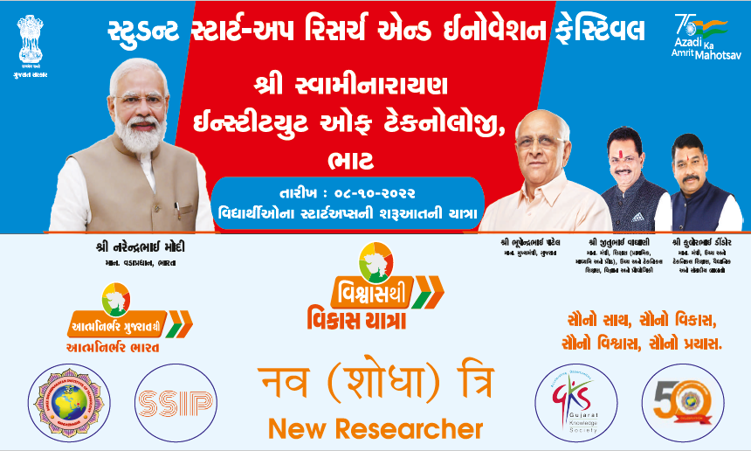

Student Startup Research and Innovation Festival
minute to minute program

Item | Duration
Arrival of chief guests and dignitaries on stage | 5 Minutes
Lighting of Lamp by Chief Guest and the dignitaries on the Dais | 10 Minutes
The Director of SSIT declares the Function Open | 10 Minutes
Felicitation of Chief Guest on the Dais | 10 Minutes
About the SSIT Incubation Center | 10 Minutes
SSIP2.0 address by the Chief Guest | 10 Minutes
Success Story of SSIT Incubation Center | 20 Minutes
Vote of Thanks by the Coordinator | 5 Minutes
National Anthem | 5 Minutes
Expert Talk | 60 Minutes

Shree Swaminarayan Institute of Technology, Bhat- Gandhinagar has organized “નવ(શોધા)ત્રિ ( Festival of Innovation)- New Researcher” as part of STUDENT START-UP RESEARCH & INNOVATION FESTIVAL on 08-10-2022 to empower the youth for the Atmanirbhar Bharat. The program was successfully inaugurated with the lighting of lamp by a group of dignitaries Chief Guest- Shri. Jaswatbhai Patel (Chairman-Standing Committee-Gandhinagar Municipal Corporation), Speaker- Mr. Jay Joshi (Program Head, i-Hub), Prof. Dharmesh Vandra(Director-SSIT), Dr. Hitesh Wandra(Principal-SSIT), Prof. Ripan Patel(Cordinator-SSIP).

Prof. Dharmesh Vandra (Director-SSIT) formally welcomed all the dignitaries present on the dais and faculties & students. He mentioned about the significance of SSIP2.0 and its aims. He motivated everyone to actively participate in the Start-up. He also described about the SSIT Incubation center activities.
Shri. Jaswatbhai Patel(Chairman-Standing Committee-GMC) described the importance of SSIP2.0. He also described different Gujarat government Scheme and new business opportunities. He also motivated everyone to actively participate in the Innovation and to get benefit. He encouraged the students to take up the challenge of perusing entrepreneurial carrier.
Shri. Jaswatbhai Patel and Mr. jay Joshi have Felicitate the Success Star-up at SSIT Incubation Center.
In the end, Prof. Ripan Patel offered a vote of thanks to all including Chief Guest- Shri. Jaswatbhai Patel), Speaker- Mr. Jay Joshi Prof. Dharmesh Vandra(Director-SSIT), Dr. Hitesh Wandra(Principal-SSIT). He also thanked SSIT Parivar for providing all kind of facilities to conduct such event in the centre.
Speaker- Mr. Jay Joshi (Program Head, i-Hub) take the session for 1 hour on New Researcher. More than 100 students was present. Where he has focused on
- SSIP2.0 Policy and Fund
- Start with a great Idea…….
- Make a Business Plan…….
- Secure Funding for your Start-up……
- Develop a marketing Plan…

Photo Gallery
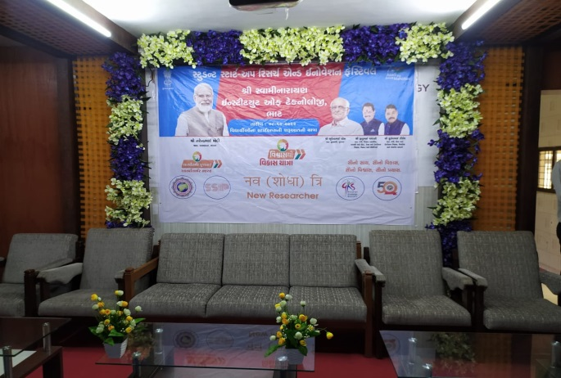 | 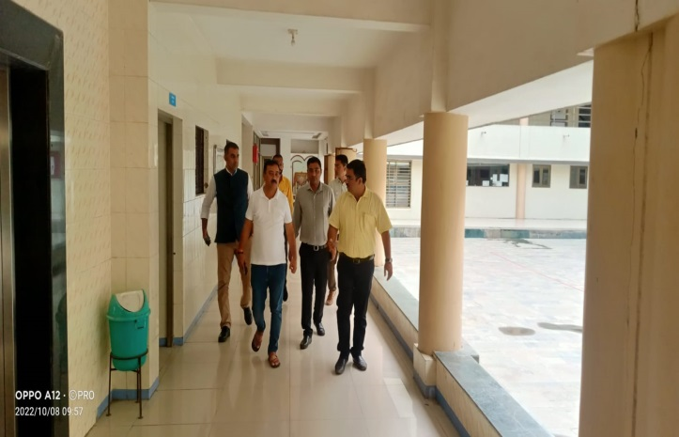
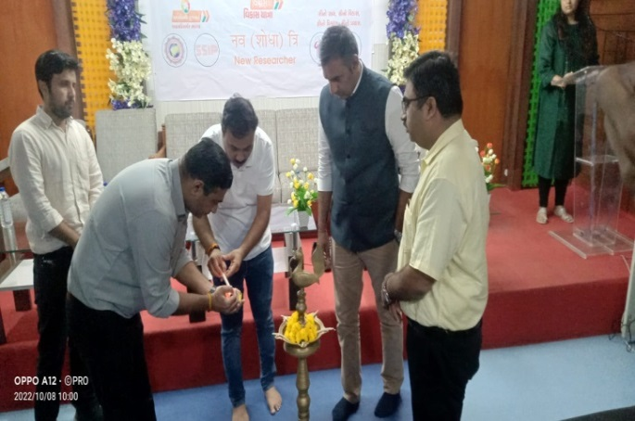 | 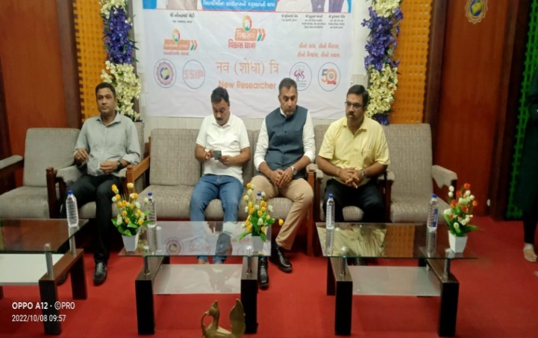
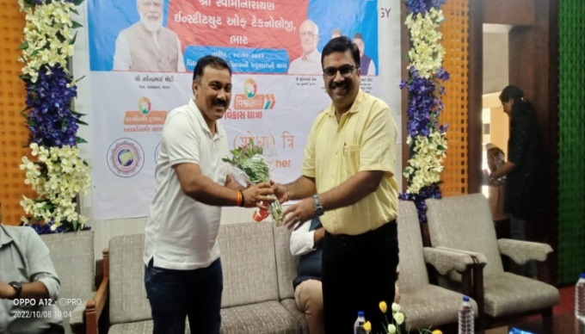 | 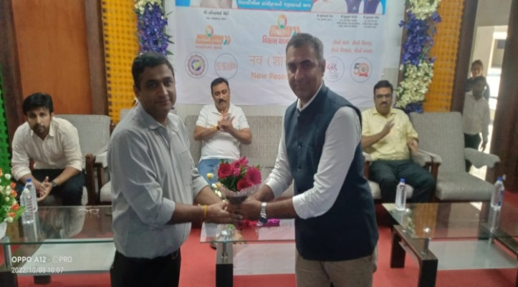
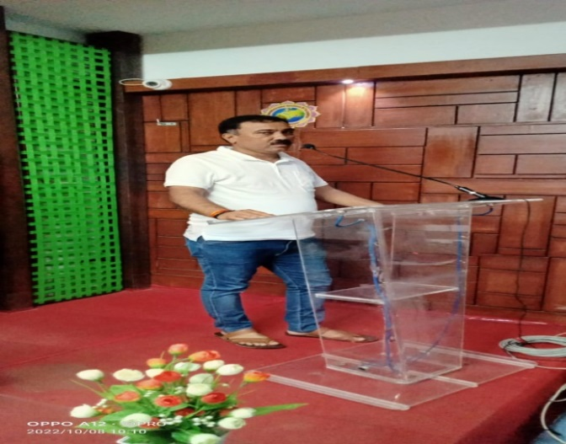 | 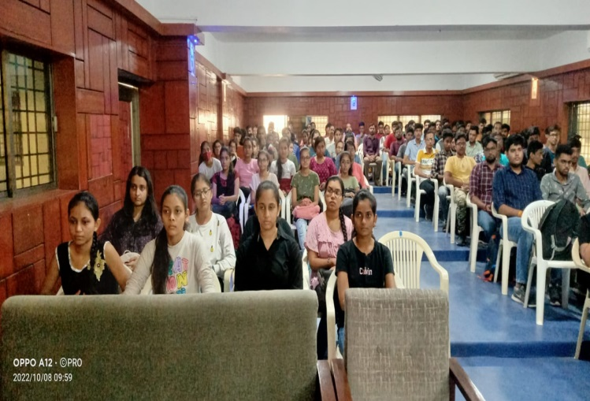

Felicitation of Success Star-up at SSIT Incubation Center
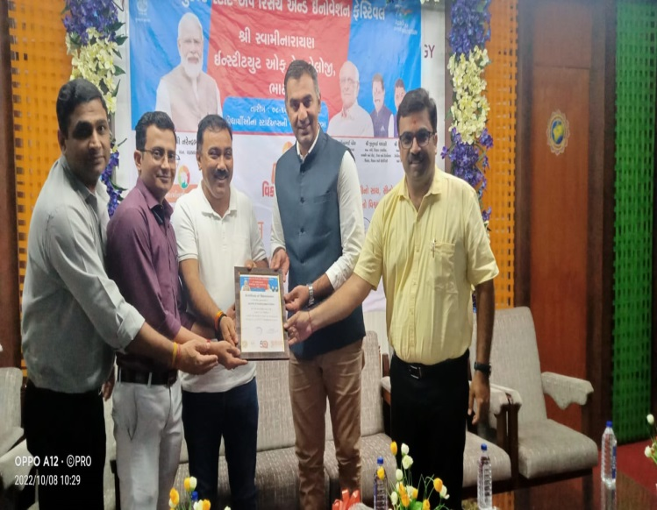 | 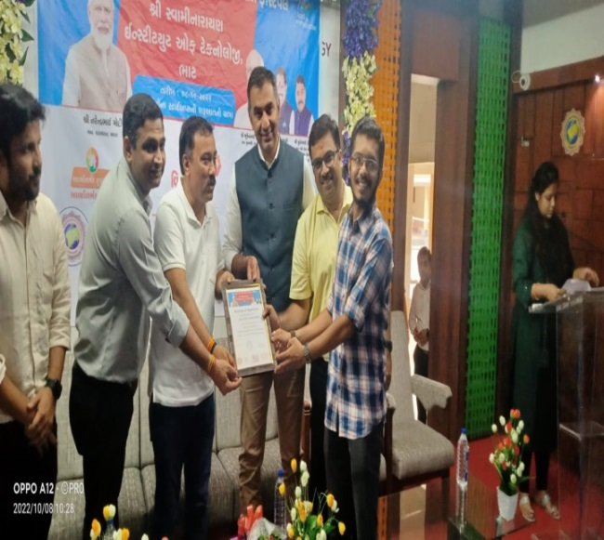
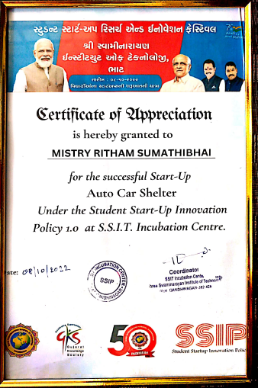 | 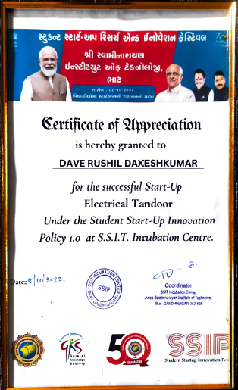
Student Name : Mistry Ridham  Prototype : Autocare Shelters:  Autocare shelters provide portable (Folding) car parking garage to those people, who don’t have their parking place. People facing lot of problem of bird drop, scratching, sunlight in summer and rain. To overcome this problem Autocare shelters is best option. His annual turnover is 5 lakh and he is planning to increase it by 10 lakh in coming Year. | Student Name: Dave Rushil  Prototype : Electric Tandoor  The main objective is to develop a new blacksmith furnace, which can increase the efficiency by reduce the heat loss of present furnace. In this blacksmith furnace, the cost is not so high and affordable to normal blacksmiths. Maintenance is very low. Assembly is very simple. His annual turnover is 3 lakh and he is planning to increase it by 10 lakh in coming Year.

Media Coverage

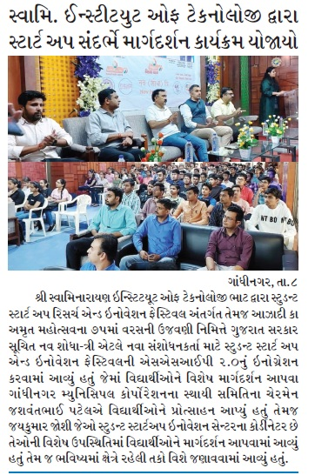 | 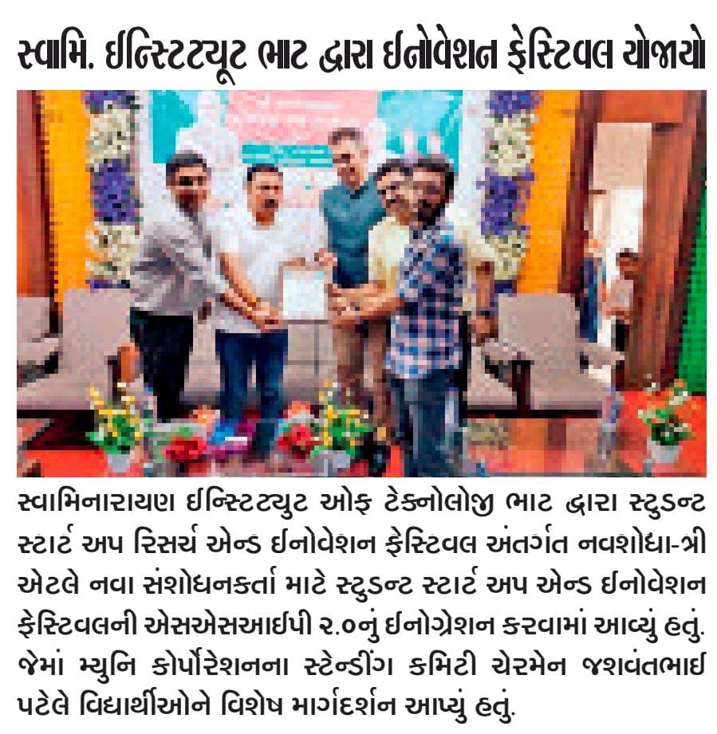

Sr. No | Enroll No | Name of Participant | Sem | Branch | Event
1 | 211250116001 | PATEL SMIT MINESHKUMAR | 3rd Sem | IT | First day : Shailputri- Introspection
2 | 211250116002 | PATEL DAKSH ROHITKUMAR | 3rd Sem | IT
3 | 211250116003 | BABARIYA DEVANSHU BHAVESHBHAI | 3rd Sem | IT
4 | 211250116004 | Prajapati Gautam Minaxiben | 3rd Sem | IT
5 | 211250116006 | Patel Yash Pravinbhai | 3rd Sem | IT
6 | 211250116007 | DOMADIYA MEET VIMALBHAI | 3rd Sem | IT
7 | 211250116008 | PATEL JAY ASHOKBHAI | 3rd Sem | IT
8 | 211250116009 | PRAJAPATI DARSHANKUMAR | 3rd Sem | IT
9 | 211250116010 | Patel Zeelkumar Prakashkumar | 3rd Sem | IT
10 | 211250116011 | SAPARIYA URVI RAJESHBHAI | 3rd Sem | IT
11 | 211250116012 | PATEL NEHANG PRAKASHBHAI | 3rd Sem | IT
12 | 211250116013 | PATEL RENA HARSHADKUMAR | 3rd Sem | IT
13 | 211250116014 | Borisa Adhya Sunil | 3rd Sem | IT
14 | 211250116015 | MANGLANI VIVEK DILIP | 3rd Sem | IT
15 | 211250116016 | PATEL VIDHI ASHVINKUMAR | 3rd Sem | IT
16 | 211250116017 | RATHOD DIYABEN RAMESHBHAI | 3rd Sem | IT
17 | 211250116018 | DABHI TIRTHRAJSINH RAJENDRASINH | 3rd Sem | IT
18 | 211250116019 | SUTHAR DIVY BHARATBHAI | 3rd Sem | IT
19 | 211250116020 | PATEL URVIL ANILBHAI | 3rd Sem | IT
20 | 211250116021 | PRAJAPATI VINIT RAJESHBHAI | 3rd Sem | IT
21 | 211250116022 | SAIYED RAHIL RIYAZAHMED | 3rd Sem | IT
22 | 211250116023 | TOMAR NITIN K. BRIJENDRA SINGH | 3rd Sem | IT
23 | 211250116024 | CHAUDHARY VISHAL SURESHKUMAR | 3rd Sem | IT
24 | 211250116025 | TOMAR ABHAY SUBODHSINGH | 3rd Sem | IT
25 | 211250116026 | GUPTA VIVEKKUMAR JITENDRAKUMAR | 3rd Sem | IT
26 | 211250116027 | JOSHI VANSHIL VISHAL | 3rd Sem | IT
27 | 211250116028 | PATEL NEER JAYANTIBHAI | 3rd Sem | IT
28 | 211250116029 | PATEL MAITRI HARESHBHAI | 3rd Sem | IT
29 | 211250116030 | KUMPAVAT KEVALSINH SUBHASHSINH | 3rd Sem | IT
30 | 211250116031 | PATEL AYUSH ASHVINKUMAR | 3rd Sem | IT
31 | 211250116032 | VAGHELA JAYPRAKASH KANJIBHAI | 3rd Sem | IT
32 | 211250116033 | PATEL TEJ JAYESHBHAI | 3rd Sem | IT
33 | 211250116034 | KUCHARA RAJAT RASIKLAL | 3rd Sem | IT
34 | 211250116035 | PRAJAPATI SMIT MANOJBHAI | 3rd Sem | IT
35 | 211250116036 | SHAH HET VIPULKUMAR | 3rd Sem | IT
36 | 211250116037 | THAKOR AMITSINHJI CHANDUJI | 3rd Sem | IT
37 | 211250116038 | KADIA DEEP BHAVESHBHAI | 3rd Sem | IT
38 | 211250116039 | PATEL MAULYA VISHNUKUMAR | 3rd Sem | IT
39 | 211250116040 | PANKHANIYA YAGNESH SATISHKUMAR | 3rd Sem | IT
40 | 211250116041 | PATEL PARTH KAUSHIKBHAI | 3rd Sem | IT
41 | 211250116043 | PATEL MEET SURESHKUMAR | 3rd Sem | IT
42 | 211250116044 | BARIA KRISHNA DIVYANAND | 3rd Sem | IT
43 | 211250116046 | PARMAR PARTHKUMAR | 3rd Sem | IT
44 | 211250116047 | PATEL VRAJ MINESHKUMAR | 3rd Sem | IT
45 | 211250116049 | BADRESHIYA PARTHIV RASHIKBHAI | 3rd Sem | IT
46 | 211250116050 | CHAVDA DHANLAXMI KAMLESHBHAI | 3rd Sem | IT
47 | 211250116052 | RUDANI VAIBHAV CHETANBHAI | 3rd Sem | IT
48 | 211250116053 | PATEL MAHARSHI ASHOKKUMAR | 3rd Sem | CE
49 | 211250116055 | Harsh Mishra | 3rd Sem | CE
50 | 211250116057 | PATEL SAKSHI RAVINDRABHAI | 3rd Sem | CE
51 | 211250107025 | Lohana Harsh | 3rd Sem | CE
52 | 211250107026 | PANARA KRISHABEN MANOJKUMAR | 3rd Sem | CE
53 | 211250107027 | PRAJAPATI MOHITKUMAR GUNVANTBHAI | 3rd Sem | CE
54 | 211250107028 | SINGH RISHAVKUMAR SHIVKUMAR | 3rd Sem | CE
55 | 211250107029 | ISRANI SIMRAN HARESHKUMAR | 3rd Sem | CE
56 | 211250107030 | PARIKH DHRUMI RAJESH | 3rd Sem | CE
57 | 211250107031 | SHARMA PANKAJ RAJUBHAI | 3rd Sem | CE
58 | 211250107032 | MAURYA KAUSHIKKUMAR RAJESH | 3rd Sem | CE
59 | 211250107034 | MAURYA NARENDRAKUMAR RAJESH | 3rd Sem | CE
60 | 211250107035 | PATEL VEDKUMAR ASHOKKUMAR | 3rd Sem | CE
61 | 201250107001 | Manvi Nitinkumar Patel | 5th Sem | CE | Second Day: Mata Bhramcharini-Determination
62 | 201250107002 | Shivam kumar | 5th Sem | CE
63 | 201250107003 | PARMAR DEVANSHU RAJESHBHAI | 5th Sem | CE
64 | 201250107004 | Sindhi Divya Manojkumar | 5th Sem | CE
65 | 201250107005 | Patel Shruti J | 5th Sem | CE
66 | 201250107006 | PATEL PARTH AKSHAYBHAI | 5th Sem | CE
67 | 201250107007 | Samarth Kamesh Raval | 5th Sem | CE
68 | 201250107008 | PATEL FENIL PANKAJBHAI | 5th Sem | CE
69 | 201250107009 | Sakshi Patel | 5th Sem | CE
70 | 201250107010 | Zinkal patel | 5th Sem | CE
71 | 201250107011 | Diya bhavsar | 5th Sem | CE
72 | 201250107012 | Kadia Nikhil Hasmukhbhai | 5th Sem | CE
73 | 201250107013 | Ravi Chandegara | 5th Sem | CE
74 | 201250107014 | Patel Sahil Pankajbhai | 5th Sem | CE
75 | 201250107015 | Alagiya bhargav P | 5th Sem | CE
76 | 201250107016 | PATEL SAHIL RASIKBHAI | 5th Sem | CE
77 | 201250107017 | Panchal sahil | 5th Sem | CE
78 | 201250107019 | Ayush | 5th Sem | CE
79 | 201250107020 | Patel Kunj Kalpeshbhai | 5th Sem | CE
80 | 201250107021 | Gajera Srushti | 5th Sem | CE
81 | 201250107022 | Disha Patel | 5th Sem | CE
82 | 201250107024 | Patel Namra | 5th Sem | CE
83 | 201250107025 | NIDHI PATEL | 5th Sem | CE
84 | 201250107026 | Jadeja Rajdipsinh N. | 5th Sem | CE
85 | 201250107027 | PATEL ARPITKUMAR KIRITBHAI | 5th Sem | CE
86 | 201250107028 | Gupta Sanjana | 5th Sem | CE
87 | 201250107029 | Priyanshu Anilkumar Sharma | 5th Sem | CE
88 | 201250107030 | Aailasingani Sahil T. | 5th Sem | CE
89 | 201250107031 | GOHIL VIDHI VIPULBHAI | 5th Sem | CE
90 | 201250107032 | KATHAROTIYA NIRAV ASHWINBHAI | 5th Sem | CE
91 | 201250107033 | Gadhavi Pradeepsinh Kailashsinh | 5th Sem | CE
92 | 201250107034 | Astha Sunil Pandey | 5th Sem | CE
93 | 201250107036 | Pachani Harsh Pravinbhai | 5th Sem | CE
94 | 201250107037 | Harsh vyas | 5th Sem | CE
95 | 201250107040 | Doda Dev Ravindra | 5th Sem | CE
96 | 201250107041 | Devdutt Bhaveshkumar Panchal | 5th Sem | CE
97 | 201250107042 | CHAUHAN PRANAV PRAVINBHAI | 5th Sem | CE
98 | 201250107043 | TEKWANI HIMANSHU KESHAVBHAI | 5th Sem | CE
99 | 201250107044 | Kumawat vasudev Rewataram | 5th Sem | CE
100 | 201250107046 | MALI SAMIR HARISHBHAI | 5th Sem | CE
101 | 201250107047 | Prasad Raviraj | 5th Sem | CE
102 | 201250107048 | PARMAR SHIVAM ARVINDBHAI | 5th Sem | CE
103 | 201250107050 | Sahil Maurya | 5th Sem | CE
104 | 201250107051 | PANCHAL JAY JAGDISHBHAI | 5th Sem | CE
105 | 201250107053 | Prajapati prem k | 5th Sem | CE
106 | 201250107054 | Prajapati yash Prakashbhai | 5th Sem | CE
107 | 201250107055 | Preya | 5th Sem | CE
108 | 201250107056 | Harsh chuahan | 5th Sem | CE
109 | 201250107057 | PATEL YASH KAMLESHBHAI | 5th Sem | CE
110 | 201250107058 | PATEL VEDANT PRAMESHKUMAR | 5th Sem | CE
111 | 201250107059 | GHUMALIYA VISHV VIRJIBHAI | 5th Sem | CE
112 | 211250107501 | KUNADIYA NEHA JITESHBHAI | 5th Sem | CE
113 | 211250107502 | GARASIA CHANDANI KALUSINH | 5th Sem | CE
114 | 211250107503 | PATEL RUTVI VISHALBHAI | 5th Sem | CE
115 | 211250107504 | SUVAGIYA KUNAL CHIMANBHAI | 5th Sem | CE
116 | 211250107505 | CHAUDHARI TORALBEN RANCHHODBHAI | 5th Sem | CE
117 | 211250107507 | PATHAN NOMANKHAN HABIBKHAN | 5th Sem | CE
118 | 211250107508 | PATEL SAKSHI ASHISHKUMAR | 5th Sem | CE
119 | 211250107509 | NAYAK SMIT KAMLESHBHAI | 5th Sem | CE
120 | 211250107510 | BAROT SACHINKUMAR PRAVINKUMAR | 5th Sem | CE
121 | 211250107511 | KAPADI SURESHBHAI RAMESHJI | 5th Sem | CE
122 | 211250107512 | PARMAR VINAYKUMAR JAGDISHBHAI | 5th Sem | CE
123 | 211250107513 | PATEL ROSHANI KALPESHKUMAR | 5th Sem | CE
124 | 211250107514 | PRAJAPATI FRESTI MUKESHBHAI | 5th Sem | CE
125 | 211250107515 | CHAUHAN VIGNESHSINH HARSHADSINH | 5th Sem | CE
126 | 211250107516 | MALI SHRUTI AJAYBHAI | 5th Sem | CE
127 | 211250107517 | MEGH NIRAV JANI | 5th Sem | CE
128 | 211250107518 | RAVAL TILAK | 5th Sem | CE
129 | 211250107519 | CHAUHAN HARSHKUMAR RAJESHBHAI | 5th Sem | CE
130 | 211250107520 | SHARMA BHAVY NILESHKUMAR | 5th Sem | CE
131 | 221250116001 | AKOLIYA JAY KAMLESHBHAI | 1 sem | IT | Third day: Mata Chandraghanta-Vigilance
132 | 221250116002 | BAROT HETVI ANILKUMAR | 1 sem | IT
133 | 221250116003 | BHATT DEV KAUSHIKBHAI | 1 sem | IT
134 | 221250116004 | BHUVA DEEP RAJESHKUMAR | 1 sem | IT
135 | 221250116005 | DAVE BHARGAVI MAYURBHAI | 1 sem | IT
136 | 221250116006 | DESAI MIHIRKUMAR PRAFULBHAI | 1 sem | IT
137 | 221250116007 | DHANKECHA JENIL JITENDRABHAI | 1 sem | IT
138 | 221250116008 | DUBEY KAUSHAL SATENDRA | 1 sem | IT
139 | 221250116009 | GAJERA NIDHIBEN JAYANTILAL | 1 sem | IT
140 | 221250116010 | GOSWAMI DEVBHARTI NAYANBHARTI | 1 sem | IT
141 | 221250116011 | HET PATEL | 1 sem | IT
142 | 221250116012 | JETHVA DARSHAN JAGDISHBHAI | 1 sem | IT
143 | 221250116013 | KHANPARA DRASHTIBEN YOGESHBHAI | 1 sem | IT
144 | 221250116014 | KORIYA MINAL ASHOKBHAI | 1 sem | IT
145 | 221250116015 | KOTADIYA BHARGAV VIJAYBHAI | 1 sem | IT
146 | 221250116016 | KSHATRIYA PRATIKSINGH VIRENDRASINGH | 1 sem | IT
147 | 221250116017 | MEHTA DAKSH CHIRAGBHAI | 1 sem | IT
148 | 221250116018 | NEHA KETANKUMAR BHATT | 1 sem | IT
149 | 221250116019 | ODD ANAND VIJAYBHAI | 1 sem | IT
150 | 221250116020 | PAL CHITRA DILIPSINH | 1 sem | IT
151 | 221250116021 | PALALIYA DEVARSH KIRANBHAI | 1 sem | IT
152 | 221250116022 | PANCHAL KRISHNA BHARATKUMAR | 1 sem | IT
153 | 221250116023 | PANCHAL VISHAL MAHENDRAKUMAR | 1 sem | IT
154 | 221250116024 | PARMAR YUVRAJSINH PREMJIBHAI | 1 sem | IT
155 | 221250116025 | PATEL AKASHKUMAR MAHESHBHAI | 1 sem | IT
156 | 221250116026 | PATEL ANJALIBEN RAVINDRAKUMAR | 1 sem | IT
157 | 221250116027 | PATEL ARYAN HEMANTBHAI | 1 sem | IT
158 | 221250116028 | PATEL DEVSHREE ALPESHKUMAR | 1 sem | IT
159 | 221250116029 | PATEL DHRUV JAGDISHBHAI | 1 sem | IT
160 | 221250116030 | PATEL DHRUVI NILESHKUMAR | 1 sem | IT
161 | 221250116031 | PATEL HARSHKUMAR PANKAJKUMAR | 1 sem | IT
162 | 221250116032 | PATEL JIGAR RAKESHKUMAR | 1 sem | IT
163 | 221250116033 | PATEL KARMKUMAR PANKAJKUMAR | 1 sem | IT
164 | 221250116034 | PATEL SMEET VIPULBHAI | 1 sem | IT
165 | 221250116035 | PATEL SUJAL CHETANBHAI | 1 sem | IT
166 | 221250116036 | PATEL SUJAL MAHESHBHAI | 1 sem | IT
167 | 221250116037 | PATEL YAKSH MUKESHBHAI | 1 sem | IT
168 | 221250116038 | RADADIYA RITUL ASHOKBHAI | 1 sem | IT
169 | 221250116039 | RAJPUT SANJANA SHASHIBHUSAN | 1 sem | IT
170 | 221250116041 | RAO SHALIN VIRENDRASINH | 1 sem | IT
171 | 221250116042 | RATHOD KRISH PRATAPBHAI | 1 sem | IT
172 | 221250116043 | SAVALIYA SUJAL GUNJANBHAI | 1 sem | IT
173 | 221250116044 | SHARMA BHAVIK PRADIP | 1 sem | IT
174 | 221250116045 | SOLANKI KRUSHNASINH LABHUBHAI | 1 sem | IT
175 | 221250116046 | SUTHAR PRATHAM MAHENDRA | 1 sem | CE
176 | 221250116047 | SUTHAR SUJAL VIJAYKUMAR | 1 sem | CE
177 | 221250116048 | SUTHAR YASH CHAMPAKKUMAR | 1 sem | CE
178 | 221250116049 | THAKUR SAUMYASINGH RAJESHSINGH | 1 sem | CE
179 | 221250116050 | TIRTH YOMESHKUMAR PATEL | 1 sem | CE
180 | 221250116051 | TIWARI ARUN SANJIVKUMAR | 1 sem | CE
181 | 221250116052 | TRADA MONIKA ARVINDBHAI | 1 sem | CE
182 | 221250116053 | VAGHASIYA VRAJ KIRITBHAI | 1 sem | CE
183 | 221250116054 | VAISHNAV SHRUTI PRAKASH | 1 sem | CE
184 | 221250116055 | VYAS HELI HITESHKUMAR | 1 sem | CE
185 | 221250116056 | YADAV RAKESH NARAYAN BHAI | 1 sem | CE
186 | 221250116057 | DARSHAN PATEL | 1 sem | CE
187 | 221250116058 | PATEL DHRUMIL SURESHBHAI | 1 sem | CE
188 | 221250107002 | BHADORIYA KHUSHI ANILSINH | 1 sem | CE
189 | 221250107003 | BHOOMI PARMAR | 1 sem | CE
190 | 221250107004 | BRAHMBHATT DRUPESH RAJESHKUMAR | 1 sem | CE
191 | 221250107005 | CHAUDHARY DEV ABHUBHAI | 1 sem | CE
192 | 221250107007 | GADHAVI VIDHAN JANAKKUMAR | 1 sem | CE
193 | 221250107008 | GAJERA VIVEK PARESHBHAI | 1 sem | CE
194 | 221250107009 | GUPTA SHRESTHA HARIOM | 1 sem | CE
195 | 221250107010 | HIMANSHU TIWARI | 1 sem | CE
196 | 221250107011 | JETHVA AASTHA RAJNIKANT | 1 sem | CE
197 | 221250107012 | KADAM AADITYA DEEPAK | 1 sem | CE
198 | 221250107013 | KAPADIYA SUJAL PRAVIN | 1 sem | CE
199 | 221250107014 | KIRTAN TANTI | 1 sem | CE
200 | 221250107015 | KURESHI MAHAMADA ADIL IBRAHEEMMAHAMADA | 1 sem | CE
201 | 221250107016 | MAURYA SUMIT RAMNATH | 1 sem | CE
202 | 221250107017 | MEHTA HEERKUMAR PAVANKUMAR | 1 sem | CE
203 | 221250107018 | MOURYA ALOK PREMCHANDRABHAI | 1 sem | CE
204 | 221250107019 | NARSINGHANI RINKALBEN BHAGAVANDAS | 1 sem | CE
205 | 221250107020 | PANCHAL HET RAKESHBHAI | 1 sem | CE
206 | 221250107021 | PATEL ANKIT HASMUKHBHAI | 1 sem | CE
207 | 221250107022 | PATEL ARYAN HITESHBHAI | 1 sem | CE
208 | 221250107023 | AYUSH PATEL | 1 sem | CE
209 | 221250107024 | PATEL DEEYA DHIRAJKUMAR | 1 sem | CE
210 | 221250107057 | VAIDEHI THAKKAR | 1 sem | CE
211 | 221253106002 | &nbspAAHIR BHAGIRATH | 3rd sem | Civil | Six, Seven and Eight Day: Mata Katyayani, Kaalratri, Mahagauri -fighting spirit, overcome difficulty, grooming and charisma
212 | 221253106001 | &nbspATIT HARSH | 3rd sem | Civil
213 | 211250106007 | &nbspBHARWAD KUSH | 3rd sem | Civil
214 | 211250106001 | &nbspCHAVDA HARDIK | 3rd sem | Civil
215 | 221253106003 | &nbspCHRISTI ARNIE | 3rd sem | Civil
216 | 211250106006 | &nbspDESAI YASH | 3rd sem | Civil
217 | 221253106004 | &nbspDHAMI BHAVIN | 3rd sem | Civil
218 | 221253106005 | &nbspDHANANI DHAWAN | 3rd sem | Civil
219 | 221253106006 | &nbspDHVIJ KHUSHI | 3rd sem | Civil
220 | 221253106007 | &nbspGAJJAR PARTHIV | 3rd sem | Civil
221 | 221253106008 | &nbspHADA JAYDEEPSINH | 3rd sem | Civil
222 | 221253106009 | &nbspHADAGADA NAVGHANBHAI | 3rd sem | Civil
223 | 221253106010 | &nbspJOGANI YASH | 3rd sem | Civil
224 | 221253106011 | &nbspKODIYATAR VIJAY | 3rd sem | Civil
225 | 211250106009 | &nbspKORI DHRUV | 3rd sem | Civil
226 | 221253106012 | &nbspKUMAVAT NEHAL | 3rd sem | Civil
227 | 221253106013 | &nbspMAHETA YASH | 3rd sem | Civil
228 | 221253106014 | &nbspMAKVANA JYOTIBEN | 3rd sem | Civil
229 | 221253106015 | &nbspMAKWANA BHARATKUMAR | 3rd sem | Civil
230 | 221253106016 | &nbspMEHTA PRIYANKA | 3rd sem | Civil
231 | 221253106017 | &nbspMODI HAPPYBEN | 3rd sem | Civil
232 | 221253106018 | &nbspMOHOD KARAN | 3rd sem | Civil
233 | 221253106019 | &nbspPANCHAL AKHIL | 3rd sem | Civil
234 | 221253106020 | &nbspPANCHAL MEET | 3rd sem | Civil
235 | 221253106021 | &nbspPANDYA PRIYANSHEE | 3rd sem | Civil
236 | 221253106022 | &nbspPARMAR INDRAJEETSINH | 3rd sem | Civil
237 | 221253106024 | &nbspPARMAR SAGARBHAI | 3rd sem | Civil
238 | 211250106002 | &nbspPARMAR SHAILESHKUMAR | 3rd sem | Civil
239 | 221253106023 | &nbspPARMAR PRINCY | 3rd sem | Civil
240 | 221253106043 | &nbspPARMAR NISHANT | 3rd sem | Civil
241 | 221253106025 | &nbspPARMAR SHRIKANT KUMAR | 3rd sem | Civil
242 | 211250106005 | &nbspPATEL MIHIR | 3rd sem | Civil
243 | 221253106026 | &nbspPATEL HIRALKUMAR | 3rd sem | Civil
244 | 211250106003 | &nbspPATEL VAIDIKKUMAR | 3rd sem | Civil
245 | 221253106027 | &nbspPATEL KASHYAP | 3rd sem | Civil
246 | 211250106010 | &nbspPATEL TANMAY | 3rd sem | Civil
247 | 211250106004 | &nbspPATEL URVA | 3rd sem | Civil
248 | 221253106029 | &nbspPATEL TARANGKUMAR | 3rd sem | Civil
249 | 221253106028 | &nbspPATEL ROUMIL | 3rd sem | Civil
250 | 211250106012 | &nbspPATEL KASHYAP | 3rd sem | Civil
251 | 221253106030 | &nbspPRAJAPATI AMITKUMAR | 3rd sem | Civil
252 | 221253106034 | &nbspPRAJAPATI RAVIBHAI | 3rd sem | Civil
253 | 221253106032 | &nbspPRAJAPATI BRIJESH | 3rd sem | Civil
254 | 221253106033 | &nbspPRAJAPATI DHRUVKUMAR | 3rd sem | Civil
255 | 221253106031 | &nbspPRAJAPATI BIRVA | 3rd sem | Civil
256 | 221253106035 | &nbspPRATIK DEEPAKBHAI | 3rd sem | Civil
257 | 211250106013 | &nbspRAIYANI CHIRAGKUMAR | 3rd sem | Civil
258 | 221253106036 | &nbspSHAH PARTH | 3rd sem | Civil
259 | 221253106037 | &nbspSHAH PRITKUMAR | 3rd sem | Civil
260 |  | &nbspSHAH PARTH | 3rd sem | Civil
261 | 221253106038 | &nbspSHROFF PRINCE | 3rd sem | Civil
262 | 221253106039 | &nbspSOLANKI HARSHIL | 3rd sem | Civil
263 | 211250106011 | &nbspTHAKOR SUMEGHKUMAR | 3rd sem | Civil
264 | 221253106040 | &nbspTORIYA DEVABHAI | 3rd sem | Civil
265 | 221253106041 | &nbspVADGAMA RUSHI | 3rd sem | Civil
266 | 221253106042 | &nbspVANIYA KETAN | 3rd sem | Civil
267 | 211250106505 | &nbspAMIN PARTH | 5th sem | Civil
268 | 211250106541 | &nbspAMIN DHARMENDRAKUMAR | 5th sem | Civil
269 | 201250106001 | &nbspCHAUHAN UMANG | 5th sem | Civil
270 | 211250106524 | &nbspDELIWALA DEVAM | 5th sem | Civil
271 | 211250106528 | &nbspFATANIYA MIHIR | 5th sem | Civil
272 | 211250106518 | &nbspGANGAWAT RIYA | 5th sem | Civil
273 | 211250106514 | &nbspGOAND SUNDARAM | 5th sem | Civil
274 | 211250106533 | &nbspHADIYEL JATIN | 5th sem | Civil
275 | 211250106513 | &nbspJADAV RONAK | 5th sem | Civil
276 | 211250106522 | &nbspKAYASTHYA OM | 5th sem | Civil
277 | 211250106512 | &nbspKORI AAKASHKUMAR | 5th sem | Civil
278 | 211250106527 | &nbspKUSHWAH AYUSHRAJ | 5th sem | Civil
279 | 211250106516 | &nbspMACHCHI DHRUVKUMAR | 5th sem | Civil
280 | 211250106529 | &nbspMAHERIYA DIXITA | 5th sem | Civil
281 | 211250106535 | &nbspMAKWANA BINAL | 5th sem | Civil
282 | 211250106540 | &nbspMAKWANA PRAVINKUMAR | 5th sem | Civil
283 | 211250106511 | &nbspNARNARAM PRAJAPATI | 5th sem | Civil
284 | 211250106515 | &nbspNAYAK VASHISHT | 5th sem | Civil
285 | 211250106521 | &nbspPARIKH KHUSHI | 5th sem | Civil
286 | 211250106510 | &nbspPARMAR HARSH | 5th sem | Civil
287 | 211250106526 | &nbspPARMAR SAMAY | 5th sem | Civil
288 | 211250106508 | &nbspPATEL TMANANNAKUMARI | 5th sem | Civil
289 | 211250106519 | &nbspPATEL DIV | 5th sem | Civil
290 | 211250106506 | &nbspPATEL ARAV | 5th sem | Civil
291 | 211250106517 | &nbspPATEL MURGENKUMAR | 5th sem | Civil
292 | 211250106503 | &nbspPATEL KISHAN | 5th sem | Civil
293 | 211250106525 | &nbspPATEL PREYASHKUMAR | 5th sem | Civil
294 | 211250106520 | &nbspPRAJAPATI KUNJALI | 5th sem | Civil
295 | 211250106523 | &nbspRAJPUT POOJA | 5th sem | Civil
296 | 211250106536 | &nbspSHRIMALI DHRUVKUMAR | 5th sem | Civil
297 | 211250106504 | &nbspSUTHAR MIHIR | 5th sem | Civil
298 | 211250106501 | &nbspVACHHETA NISHA | 5th sem | Civil
299 | 211250106507 | &nbspVASAVA UNNATIBEN | 5th sem | Civil
300 | 201250106515 | &nbspAKASH D | 5th sem | Civil
301 | 201250106503 | &nbspBAMANIYA KINJALBEN | 5th sem | Civil
302 | 191250106001 | &nbspBHAVSAR DHRUVILKUMAR | 5th sem | Civil
303 | 191250106002 | &nbspBIDWAT KUSHAL | 5th sem | Civil
304 | 201250106511 | &nbspBOSMIYA NIYATI | 5th sem | Civil
305 | 191250106003 | &nbspCHAUDHARI UTKARSH | 5th sem | Civil
306 | 191250106004 | &nbspCHAUDHARY JAIVIK | 5th sem | Civil
307 | 201250106512 | &nbspCHAUHAN KHUSHI | 5th sem | Civil
308 | 191250106005 | &nbspCHAUHAN SANDIP | 5th sem | Civil
309 | 201250106507 | &nbspCHAVDA NIHARIKABEN | 5th sem | Civil
310 | 201250106529 | &nbspCHRISTIAN STEFIYANI | 5th sem | Civil
311 | 201250106539 | &nbspDARJI RUTVIK | 5th sem | Civil
312 | 201250106508 | &nbspDAS SUJATA | 5th sem | Civil
313 | 201250106509 | &nbspDESHPANDE BHAVESH | 5th sem | Civil
314 | 201250106506 | &nbspGAJJAR SHREYANSH | 5th sem | Civil
315 | 201250106505 | &nbspGATHARAJ HIMANSHU | 5th sem | Civil
316 | 201250106510 | &nbspGOHEL NIYATI | 5th sem | Civil
317 | 201250106516 | &nbspGOL BHAGYARAJ | 5th sem | Civil
318 | 191250106007 | &nbspGUPTA NILESH | 5th sem | Civil
319 | 191250106101 | &nbspJADAUN RONISH | 5th sem | Civil
320 | 201250106514 | &nbspJAYSWAL JAHNAVI | 5th sem | Civil
321 | 201250106549 | &nbspJOSHI HARSHKUMAR | 5th sem | Civil
322 | 201250106547 | &nbspJOSHI NIKETKUMAR | 5th sem | Civil
323 | 191250106008 | &nbspKHARODIYA VEDANT | 5th sem | Civil
324 | 191250106009 | &nbspLIMBAT SHUBHAM | 5th sem | Civil
325 | 201250106554 | &nbspMACHHI BHAVIKKUMAR | 5th sem | Civil
326 | 191250106010 | &nbspMAHIDA MEETRAJSINH | 5th sem | Civil
327 | 201250106523 | &nbspMISTRY BANSARI | 5th sem | Civil
328 | 201250106533 | &nbspMISTRY AKUL | 5th sem | Civil
329 | 201250106518 | &nbspMODI SHIVAM | 5th sem | Civil
330 | 191250106011 | &nbspNAYAK DARSHIL | 5th sem | Civil
331 | 201250106528 | &nbspPANCHAL JAYMINKUMAR | 5th sem | Civil
332 | 201250106542 | &nbspPANCHAL DHRUVIL | 5th sem | Civil
333 | 201250106501 | &nbspPANDYA KRUTI | 5th sem | Civil
334 | 201250106548 | &nbspPARMAR JAYESHKUMAR | 5th sem | Civil
335 | 191250106012 | &nbspPATEL ANSHU | 5th sem | Civil
336 | 201250106535 | &nbspPATEL ARCHITA | 5th sem | Civil
337 | 201250106552 | &nbspPATEL DHANANJAY | 5th sem | Civil
338 | 191250106015 | &nbspPATEL JAY | 5th sem | Civil
339 | 191250106102 | &nbspPATEL VRUSHABH | 5th sem | Civil
340 | 201250106520 | &nbspPATEL HARDI | 5th sem | Civil
341 | 201250106532 | &nbspPATEL RUTVIK | 5th sem | Civil
342 | 201250106537 | &nbspPATEL NEEL | 5th sem | Civil
343 | 201250106545 | &nbspPATEL JAIMINKUMAR | 5th sem | Civil
344 | 191250106017 | &nbspPATODIA HARSH | 5th sem | Civil
345 | 201250106534 | &nbspPRAJAPATI JAIMIN | 5th sem | Civil
346 | 201250106543 | &nbspPRAJAPATI JAY | 5th sem | Civil
347 | 201250106521 | &nbspPRAJAPATI DIXITKUMAR | 5th sem | Civil
348 | 201250106502 | &nbspPRJAPATI BHAUMIKKUMAR | 5th sem | Civil
349 | 181250106026 | &nbspRAJ KUSH | 5th sem | Civil
350 | 181250106027 | &nbspRAJPUT DILIPKUMAR | 5th sem | Civil
351 | 201250106526 | &nbspRANA PRATYUKSH | 5th sem | Civil
352 | 201250106530 | &nbspRATHAVA UMESH | 5th sem | Civil
353 | 201250106527 | &nbspROHIT AYUSHIBEN | 5th sem | Civil
354 | 201250106517 | &nbspSELOT KIRANKUMAR | 5th sem | Civil
355 | 191250106019 | &nbspSOLANKI DHAIRYA | 5th sem | Civil
356 | 201250106504 | &nbspSOLANKI SHRUTIK | 5th sem | Civil
357 | 201250106541 | &nbspSOLANKI PRAKASH | 5th sem | Civil
358 | 191250106020 | &nbspSOLANKI KARANKUMAR | 5th sem | Civil
359 | 201250106519 | &nbspSUTHAR PARTH | 5th sem | Civil
360 | 201250106524 | &nbspVISAROLIYA DEV | 5th sem | Civil
361 | 201250106550 | &nbspVYAS DHYAN | 5th sem | Civil
362 | 201250106513 | &nbspZALA DHWANIBEN | 5th sem | Civil
363 | 221250116001 | AKOLIYA JAY KAMLESHBHAI | 1st sem | IT/CE | Nine day: Expert Talk
364 | 221250116002 | BAROT HETVI ANILKUMAR | 1st sem | IT/CE
365 | 221250116003 | BHATT DEV KAUSHIKBHAI | 1st sem | IT/CE
366 | 221250116004 | BHUVA DEEP RAJESHKUMAR | 1st sem | IT/CE
367 | 221250116005 | DAVE BHARGAVI MAYURBHAI | 1st sem | IT/CE
368 | 221250116006 | DESAI MIHIRKUMAR PRAFULBHAI | 1st sem | IT/CE
369 | 221250116007 | DHANKECHA JENIL JITENDRABHAI | 1st sem | IT/CE
370 | 221250116008 | DUBEY KAUSHAL SATENDRA | 1st sem | IT/CE
371 | 221250116009 | GAJERA NIDHIBEN JAYANTILAL | 1st sem | IT/CE
372 | 221250116010 | GOSWAMI DEVBHARTI NAYANBHARTI | 1st sem | IT/CE
373 | 221250116011 | HET PATEL | 1st sem | IT/CE
374 | 221250116012 | JETHVA DARSHAN JAGDISHBHAI | 1st sem | IT/CE
375 | 221250116013 | KHANPARA DRASHTIBEN YOGESHBHAI | 1st sem | IT/CE
376 | 221250116014 | KORIYA MINAL ASHOKBHAI | 1st sem | IT/CE
377 | 221250116015 | KOTADIYA BHARGAV VIJAYBHAI | 1st sem | IT/CE
378 | 221250116016 | KSHATRIYA PRATIKSINGH VIRENDRASINGH | 1st sem | IT/CE
379 | 221250116017 | MEHTA DAKSH CHIRAGBHAI | 1st sem | IT/CE
380 | 221250116018 | NEHA KETANKUMAR BHATT | 1st sem | IT/CE
381 | 221250116019 | ODD ANAND VIJAYBHAI | 1st sem | IT/CE
382 | 221250116020 | PAL CHITRA DILIPSINH | 1st sem | IT/CE
383 | 221250116021 | PALALIYA DEVARSH KIRANBHAI | 1st sem | IT/CE
384 | 221250116022 | PANCHAL KRISHNA BHARATKUMAR | 1st sem | IT/CE
385 | 221250116023 | PANCHAL VISHAL MAHENDRAKUMAR | 1st sem | IT/CE
386 | 221250116024 | PARMAR YUVRAJSINH PREMJIBHAI | 1st sem | IT/CE
387 | 221250116025 | PATEL AKASHKUMAR MAHESHBHAI | 1st sem | IT/CE
388 | 221250116026 | PATEL ANJALIBEN RAVINDRAKUMAR | 1st sem | IT/CE
389 | 221250116027 | PATEL ARYAN HEMANTBHAI | 1st sem | IT/CE
390 | 221250116028 | PATEL DEVSHREE ALPESHKUMAR | 1st sem | IT/CE
391 | 221250116029 | PATEL DHRUV JAGDISHBHAI | 1st sem | IT/CE
392 | 221250116030 | PATEL DHRUVI NILESHKUMAR | 1st sem | IT/CE
393 | 221250116031 | PATEL HARSHKUMAR PANKAJKUMAR | 1st sem | IT/CE
394 | 221250116032 | PATEL JIGAR RAKESHKUMAR | 1st sem | IT/CE
395 | 221250116033 | PATEL KARMKUMAR PANKAJKUMAR | 1st sem | IT/CE
396 | 221250116034 | PATEL SMEET VIPULBHAI | 1st sem | IT/CE
397 | 221250116035 | PATEL SUJAL CHETANBHAI | 1st sem | IT/CE
398 | 221250116036 | PATEL SUJAL MAHESHBHAI | 1st sem | IT/CE
399 | 221250116037 | PATEL YAKSH MUKESHBHAI | 1st sem | IT/CE
400 | 221250116038 | RADADIYA RITUL ASHOKBHAI | 1st sem | IT/CE
401 | 221250116039 | RAJPUT SANJANA SHASHIBHUSAN | 1st sem | IT/CE
402 | 221250116041 | RAO SHALIN VIRENDRASINH | 1st sem | IT/CE
403 | 221250116042 | RATHOD KRISH PRATAPBHAI | 1st sem | IT/CE
404 | 221250116043 | SAVALIYA SUJAL GUNJANBHAI | 1st sem | IT/CE
405 | 221250116044 | SHARMA BHAVIK PRADIP | 1st sem | IT/CE
406 | 221250116045 | SOLANKI KRUSHNASINH LABHUBHAI | 1st sem | IT/CE
407 | 221250116046 | SUTHAR PRATHAM MAHENDRA | 1st sem | IT/CE
408 | 221250116047 | SUTHAR SUJAL VIJAYKUMAR | 1st sem | IT/CE
409 | 221250116048 | SUTHAR YASH CHAMPAKKUMAR | 1st sem | IT/CE
410 | 221250116049 | THAKUR SAUMYASINGH RAJESHSINGH | 1st sem | IT/CE
411 | 221250116050 | TIRTH YOMESHKUMAR PATEL | 1st sem | IT/CE
412 | 221250116051 | TIWARI ARUN SANJIVKUMAR | 1st sem | IT/CE
413 | 221250116052 | TRADA MONIKA ARVINDBHAI | 1st sem | IT/CE
414 | 221250116053 | VAGHASIYA VRAJ KIRITBHAI | 1st sem | IT/CE
415 | 221250116054 | VAISHNAV SHRUTI PRAKASH | 1st sem | IT/CE
416 | 221250116055 | VYAS HELI HITESHKUMAR | 1st sem | IT/CE
417 | 221250116056 | YADAV RAKESH NARAYAN BHAI | 1st sem | IT/CE
418 | 221250116057 | DARSHAN PATEL | 1st sem | IT/CE
419 | 221250116058 | PATEL DHRUMIL SURESHBHAI | 1st sem | IT/CE
420 | 221250107002 | BHADORIYA KHUSHI ANILSINH | 1st sem | IT/CE
421 | 221250107003 | BHOOMI PARMAR | 1st sem | IT/CE
422 | 221250107004 | BRAHMBHATT DRUPESH RAJESHKUMAR | 1st sem | IT/CE
423 | 221250107005 | CHAUDHARY DEV ABHUBHAI | 1st sem | IT/CE
424 | 221250107007 | GADHAVI VIDHAN JANAKKUMAR | 1st sem | IT/CE
425 | 221250107008 | GAJERA VIVEK PARESHBHAI | 1st sem | IT/CE
426 | 221250107009 | GUPTA SHRESTHA HARIOM | 1st sem | IT/CE
427 | 221250107010 | HIMANSHU TIWARI | 1st sem | IT/CE
428 | 221250107011 | JETHVA AASTHA RAJNIKANT | 1st sem | IT/CE
429 | 221250107012 | KADAM AADITYA DEEPAK | 1st sem | IT/CE
430 | 221250107013 | KAPADIYA SUJAL PRAVIN | 1st sem | IT/CE
431 | 191250119002 | CHAUHAN RAJDEEPSINH KESHRISINH | 6th sem | MECh | Four and Fifth day :Kushmanda. ,Skandamata -wealth creation and compassion
432 | 201250119001 | DABHI RUDRASINH GURUDAYALSINH | 6th sem | MECh
433 | 201250119002 | PANCHAL VIVEK HARESHBHAI | 6th sem | MECh
434 | 201250119003 | PATEL DARSHAN YOGESHKUMAR | 6th sem | MECh
435 | 201250119005 | THAKOR DARSHAN DINESHJI | 6th sem | MECh
436 | 211250119501 | MAJJAR JAGJITSINGH SUKHWINDERSINGH | 6th sem | MECh
437 | 211250119502 | SHARMA SUNILKUMAR | 6th sem | MECh
438 | 211250119503 | JADAV KASHYAP | 6th sem | MECh
439 | 211250119504 | JAYSWAL ALKESHKUMAR KIRITKUMAR | 6th sem | MECh
440 | 211250119506 | PATEL KIRTANKUMAR PRAHLADBHAI | 6th sem | MECh
441 | 211250119507 | GAJJAR TANMAY PRAVINBHAI | 6th sem | MECh
442 | 211250119508 | MAKWANA CHIRAG RAMESHBHAI | 6th sem | MECh
443 | 211250119510 | VANZARA SUMITKUMAR | 6th sem | MECh
444 | 211250119511 | PATEL DEV RAJESHKUMAR | 6th sem | MECh
445 | 211250119513 | DAVE KEYUR RAJESHKUMAR | 6th sem | MECh
446 | 211250119515 | PATEL HET YOGESHBHAI | 6th sem | MECh
447 | 211250119516 | RATHOD KRISHNARAJSINH VAKHATSINH | 6th sem | MECh
448 | 211250119517 | PAREKH AARYA ASHISHKUMAR | 6th sem | MECh
449 | 211250119519 | MODHWADIA RAM DEVSHI | 6th sem | MECh
450 | 211250119520 | SARANG DHAVAL JAYESHBHAI | 6th sem | MECh
451 | 211250119522 | DESHMUKH GAURESH DATTATRAY | 6th sem | MECh
452 | 211250119523 | BHATT JAINEEL NILESHBHAI | 6th sem | MECh
453 | 211250119524 | BHAVSAR BINIT HEMANTKUMAR | 6th sem | MECh
454 | 211250119525 | MAKWANA CHETANBHAI KANJIBHAI | 6th sem | MECh
455 | 211250119526 | KADIA MITUL YGNESHBHAI | 6th sem | MECh
456 | 211250119527 | VAGHELA ADARSH KIRANKUMAR | 6th sem | MECh
457 | 211250119530 | PANDYA DHRUV YOGESHBHAI | 6th sem | MECh
458 | 211250119531 | PANCHAL KHODIDAS DINESHBHAI | 6th sem | MECh
459 | 211250119532 | PANCHAL HARDIK NARENDRABHAI | 6th sem | MECh
460 | 211250119534 | PATEL HARSH DHARMESHBHAI | 6th sem | MECh
461 | 211250119536 | VAGHELA NAYAN TRIKAMBHAI | 6th sem | MECh
462 | 211250119538 | MOHD YASAR SHAIKH | 6th sem | MECh
463 | 211250119540 | PATEL HITKUMAR HARISHBHAI | 6th sem | MECh
464 | 211250119541 | KORAT DEVENKUMAR VIPULBHAI | 6th sem | MECh
465 | 211250119542 | SHAIKH MO KHIZAR MO SADIK | 6th sem | MECh
466 | 211250119544 | PANCHAL PARTH RAKESHBHAI | 6th sem | MECh
467 | 211250119546 | PANCHAL VRAJ KALPESHBHAI | 6th sem | MECh
468 | 211250119547 | CHAUHAN VISHALSINGH AJITSINGH | 6th sem | MECh
469 | 211250119548 | MAHAVAR MANISHKUMAR NATTHILAL | 6th sem | MECh
470 | 211250119549 | BRAHMBHATT SHIVAM CHETAN | 6th sem | MECh
471 | 211250119551 | AMIT KUMAR | 6th sem | MECh
472 | 211250119552 | JUTHANI DHRUVIL GAJENDRABHAI | 6th sem | MECh
473 | 211250119001 | PATEL AARYAN DINESHBHAI | 4th sem | Mech
474 | 211250119002 | PANCHAL AYUSH YOGENDRAKUMAR | 4th sem | Mech
475 | 211250119003 | PATEL VED KUMAR ASHOKKUMAR | 4th sem | Mech
476 | 211250119004 | JADAV SHIVAM HASMUKHBHAI | 4th sem | Mech
477 | 211250119005 | NEELKUMAR MANOJKUMAR PATEL | 4th sem | Mech
478 | 211250119006 | PATEL RAHIL RAJNIKANT | 4th sem | Mech
479 | 211250119007 | THAKARE KALPEN SHRIDHAR | 4th sem | Mech
480 | 211250119008 | SONI ARYAN PANKAJ | 4th sem | Mech
481 | 211250119009 | JAINISH VISHUBHAI PATEL | 4th sem | Mech
482 | 211250119010 | SIDDHANT VITHALBHAI PARMAR | 4th sem | Mech
483 | 211250119011 | JADEJA VISHWARAJSINH NANUBHA | 4th sem | Mech
484 | 211250119012 | MIHIR VIRANGBHAI PRAJAPATI | 4th sem | Mech
485 | 221253119001 | AALVI HISAMUDDIN MAHMAD NAFISH | 4th sem | Mech
486 | 221253119002 | AJMERI VASIM AZAZBHAI | 4th sem | Mech
487 | 221253119003 | CHARPOT RAJNIKANT KANTILAL | 4th sem | Mech
488 | 221253119004 | CHAUDHARI KISHANKUMAR DHANRAJBHAI | 4th sem | Mech
489 | 221253119005 | CHAUHAN SAURABHKUMAR VIJAYSINH | 4th sem | Mech
490 | 221253119006 | CHAUHAN SHRAVANSINGH DULESINGH | 4th sem | Mech
491 | 221253119007 | CHAVDA JAYMIN JITENDRA | 4th sem | Mech
492 | 221253119008 | CHRISTIAN SMIT PIYUSHBHAI | 4th sem | Mech
493 | 221253119009 | DARJI MIHIR NARENDRABHAI | 4th sem | Mech
494 | 221253119010 | DEEPAK s BALANI | 4th sem | Mech
495 | 221253119011 | DESAI RITESH RAMESHBHAI | 4th sem | Mech
496 | 221253119012 | GADDAMIDI ABHISHEK RAVINDRABHAI | 4th sem | Mech
497 | 221253119014 | KACHELA HARDIKKUMAR AMARSINH | 4th sem | Mech
498 | 221253119015 | KADIYA JENIL JITENDRABHAI | 4th sem | Mech
499 | 221253119016 | KANZARIYA KALPESHBHAI JAGDISHBHAI | 4th sem | Mech
500 | 221253119017 | KESHARWANI SHIVCHARAN SEETARAM | 4th sem | Mech
501 | 221253119018 | KESHARWANI SHIVSEVAK PREMNARAYAN | 4th sem | Mech
502 | 221253119019 | KORI CHIRAG BRIJESHKUMAR | 4th sem | Mech
503 | 221253119020 | KOSHTI RUTULKUMAR DALESHKUMAR | 4th sem | Mech
504 | 221253119021 | MARATHE ROHIT VIJAY | 4th sem | Mech
505 | 221253119022 | MISTRY SWAPNIL KIRANBHAI | 4th sem | Mech
506 | 221253119023 | MODI DEVKUMAR MUKUNDKUMAR | 4th sem | Mech
507 | 221253119024 | PADMANI MEETBHAI CHANDRESHKUMAR | 4th sem | Mech
508 | 221253119025 | PANCHAL MEET JAYESHKUMAR | 4th sem | Mech
509 | 221253119026 | PANCHAL SAVAN RAJESHKUMAR | 4th sem | Mech
510 | 221253119027 | PANDEY ROHIT AJAY | 4th sem | Mech
511 | 221253119028 | PARMAR MAHAMMAD SABIR DHARBHA | 4th sem | Mech
512 | 221253119029 | PARMAR MOHAAMED SOHIL SABBHA | 4th sem | Mech
513 | 221253119030 | PATEL BHARGVEN HEMANTKUMAR | 4th sem | Mech
514 | 221253119031 | PATEL DARSH MANISHKUMAR | 4th sem | Mech
515 | 221253119032 | PATEL DHRUV DINESHBHAI | 4th sem | Mech
516 | 221253119033 | PATEL DIKENKUMAR RAJENDRABHAI | 4th sem | Mech
517 | 221253119034 | PATEL HARSH KANAIYALAL | 4th sem | Mech
518 | 221253119035 | PATEL HENIL VIKRAMBHAI | 4th sem | Mech
519 | 221253119036 | PATEL MEETKUMAR PRAVINBHAI | 4th sem | Mech
520 | 221253119037 | PATEL YASH SURESHBHAI | 4th sem | Mech
521 | 221253119040 | PRAJAPATI VINIT ARVINDBHAI | 4th sem | Mech
522 | 221253119041 | RAULJI JAYKISHANSINH JITENDRASINH | 4th sem | Mech
523 | 221253119042 | RAVAL KARTIK PRAKASHBHAI | 4th sem | Mech
524 | 221253119044 | MAURYA SANAT KUMAR | 4th sem | Mech
525 | 221253119045 | SAVALIYA BHAVIN VASHARAMBHAI | 4th sem | Mech
526 | 221253119046 | SHAH PARAS KIRTANKUMAR | 4th sem | Mech
527 | 221253119047 | SHARMA AAKASHKUMAR KALIDAS | 4th sem | Mech
528 | 221253119048 | SHARMA HIMANSHUKUMAR JITENDRABHAI | 4th sem | Mech
529 | 221253119049 | SHARMA NEEL VIPULKUMAR | 4th sem | Mech
530 | 221253119050 | SHUKLA YUVRAJ ARVINDKUMAR | 4th sem | Mech
531 | 221253119051 | SONAR sumit NARESHBHAI | 4th sem | Mech
532 | 221253119052 | SONI KHYATI RAJESHKUMAR | 4th sem | Mech
533 | 221253119053 | SUTHAR JAYKUMAR PRAFULBHAI | 4th sem | Mech
534 | 221253119054 | THAKOR ASHISH AMRUTBHAI | 4th sem | Mech
535 | 221253119055 | THAKOR JAIVIK DINESHKUMAR | 4th sem | Mech
536 | 221253119056 | THAKOR KALPESH DASHRATHBHAI | 4th sem | Mech
537 | 221253119057 | VAGHELA JAYRAJSINH DILIPSINH | 4th sem | Mech
538 | 221253119058 | VAGHELA RAHULKUMAR RAJESHBHAI | 4th sem | Mech
539 | 221253119059 | VAIDH MEHULKUMAR SATYANARAYAN | 4th sem | Mech
540 | 221253119060 | VERMA GAURAV RAKESHKUMAR | 4th sem | Mech
541 | 221253119061 | VYAS HET HITESHBHAI | 4th sem | Mech
542 | 221250106001 | BHARWAD PRINCE MUKESHBHAI | 1st sem | Civil/Mech
543 | 221250106002 | CHAUDHARI HARSHIL VISHNUBHAI | 1st sem | Civil/Mech
544 | 221250106003 | ODD SUNIL NARIRAM | 1st sem | Civil/Mech
545 | 221250106004 | PRAJAPATI JATINKUMAR KUBERBHAI | 1st sem | Civil/Mech
546 | 221250106005 | VAGHELA JAY MANUJI | 1st sem | Civil/Mech
547 | 221250119001 | ADIDRAVIDAN SUBASH PUSHPARAJAN | 1st sem | Civil/Mech
548 | 221250119003 | HARIOM VISHWAKARMA | 1st sem | Civil/Mech
549 | 221253119017 | KESHARWANI SHIVCHARAN SEETARAM | 1st sem | Civil/Mech
550 | 221253119018 | KESHARWANI SHIVSEVAK PREMNARAYAN | 1st sem | Civil/Mech

