SOLAR CONVERSION TECHNOLOGIES: RECENT TRENDS AND ENTREPRENEURIAL OPPORTUNITIES
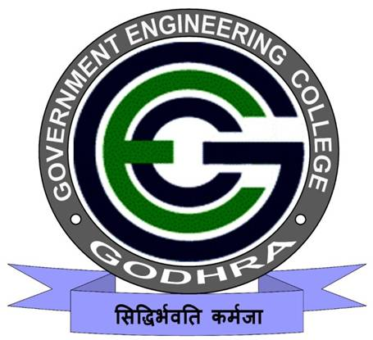
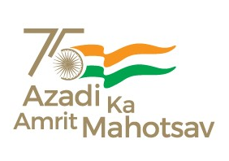
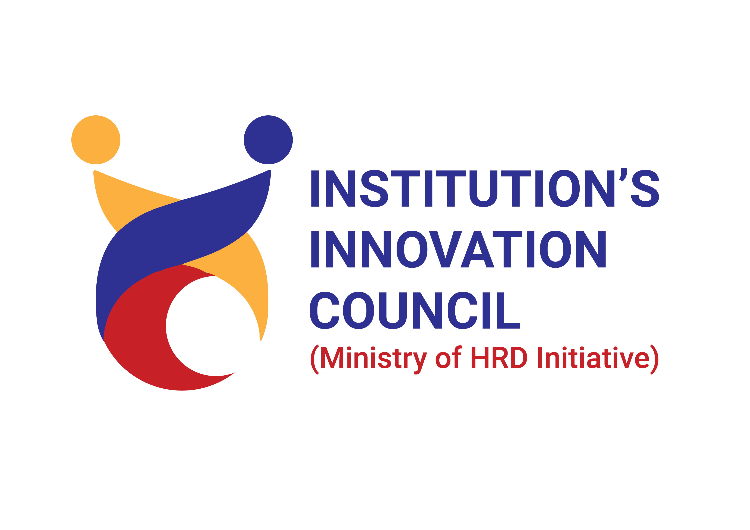
18/12/2023
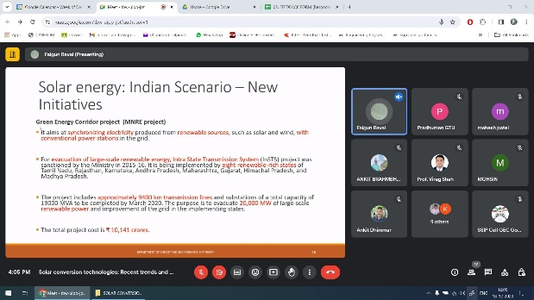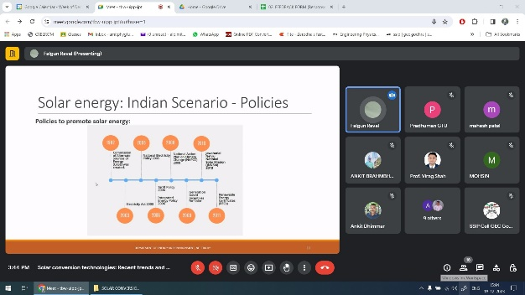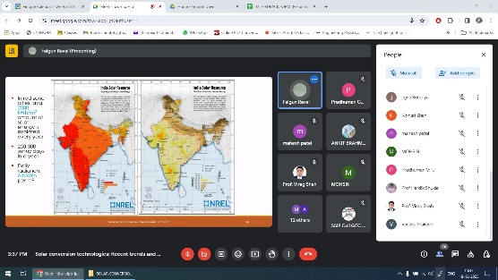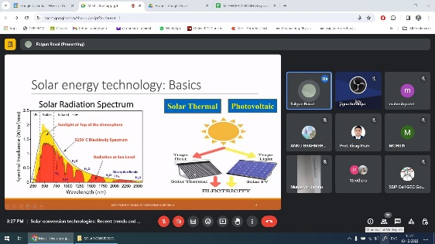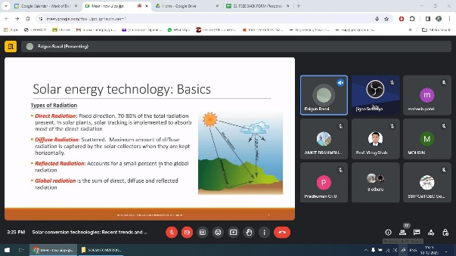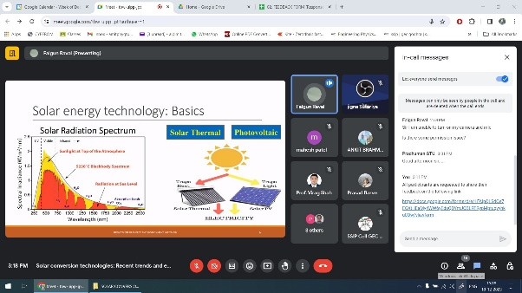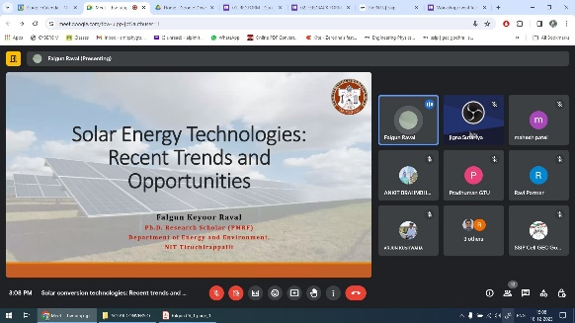
An event of “SOLAR CONVERSION TECHNOLOGIES: RECENT TRENDS AND ENTREPRENEURIAL OPPORTUNITIES” was organized by SSIP cell, Government Engineering College Godhra on 18th December, 2023.
The program was inaugurated at 03:00 pm via online platform. A total of 12 students and faculty members of all academic branches have participated in the program.
Dr. A. J. Patel, SSIP coordinator & Asst. Prof. PHYSICS introduced the expert of the program Mr Falgun Raval, Ph. D. Scholar (PMRF), Department of Energy and Environment, NIT Tiruchirappalli.
After that the expert gave a presentation explaining various types of solar conversion technologies. He also explained in detail about the entrepreneurial opportunities existing in this area.
At the end Prof. Prakash N. Vasava, Convener of the program & Asst. Prof. Mechanical Engg., GEC Godhra gave a vote of thanks to expert, SSIP team and participants.
The program was concluded with NATIONAL ANTHEM.

