INNOVATION, INVENTION & PATENT
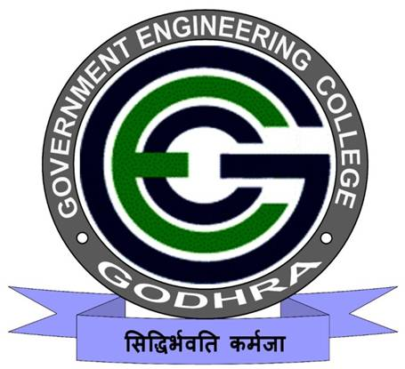
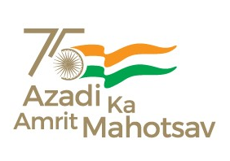
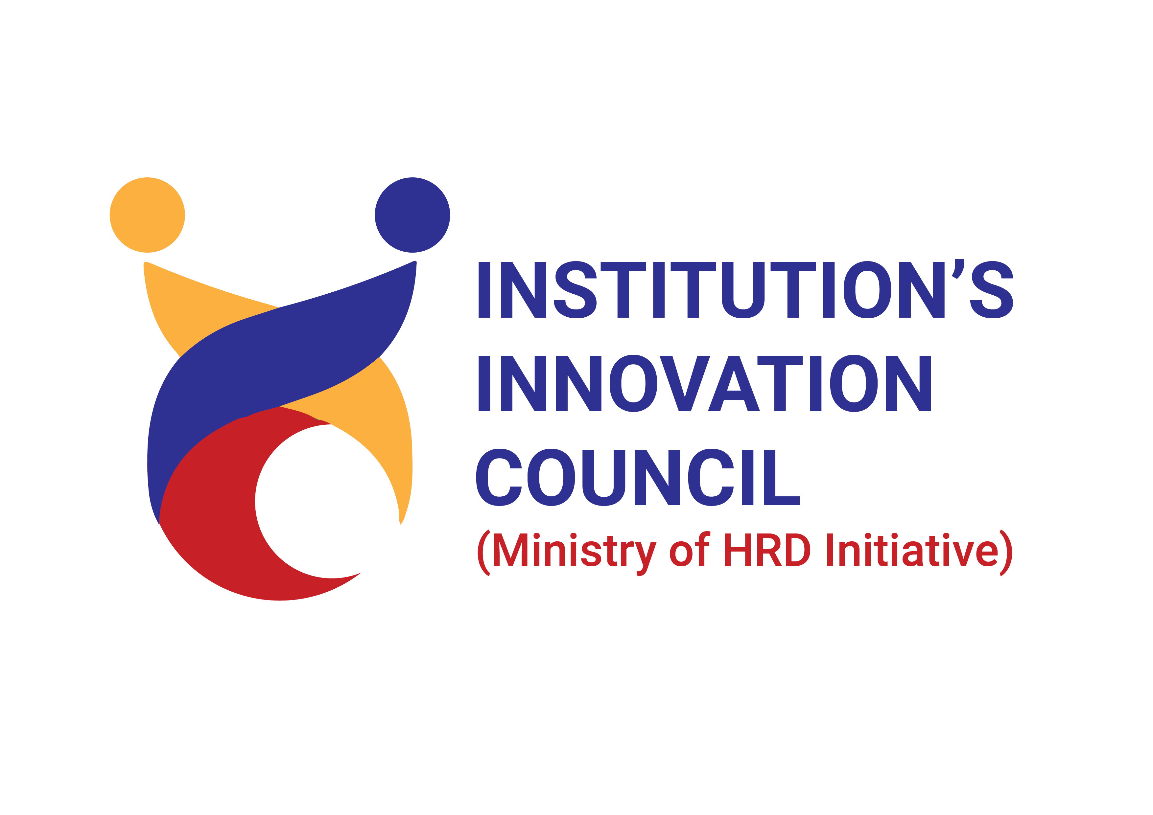
16/12/2023
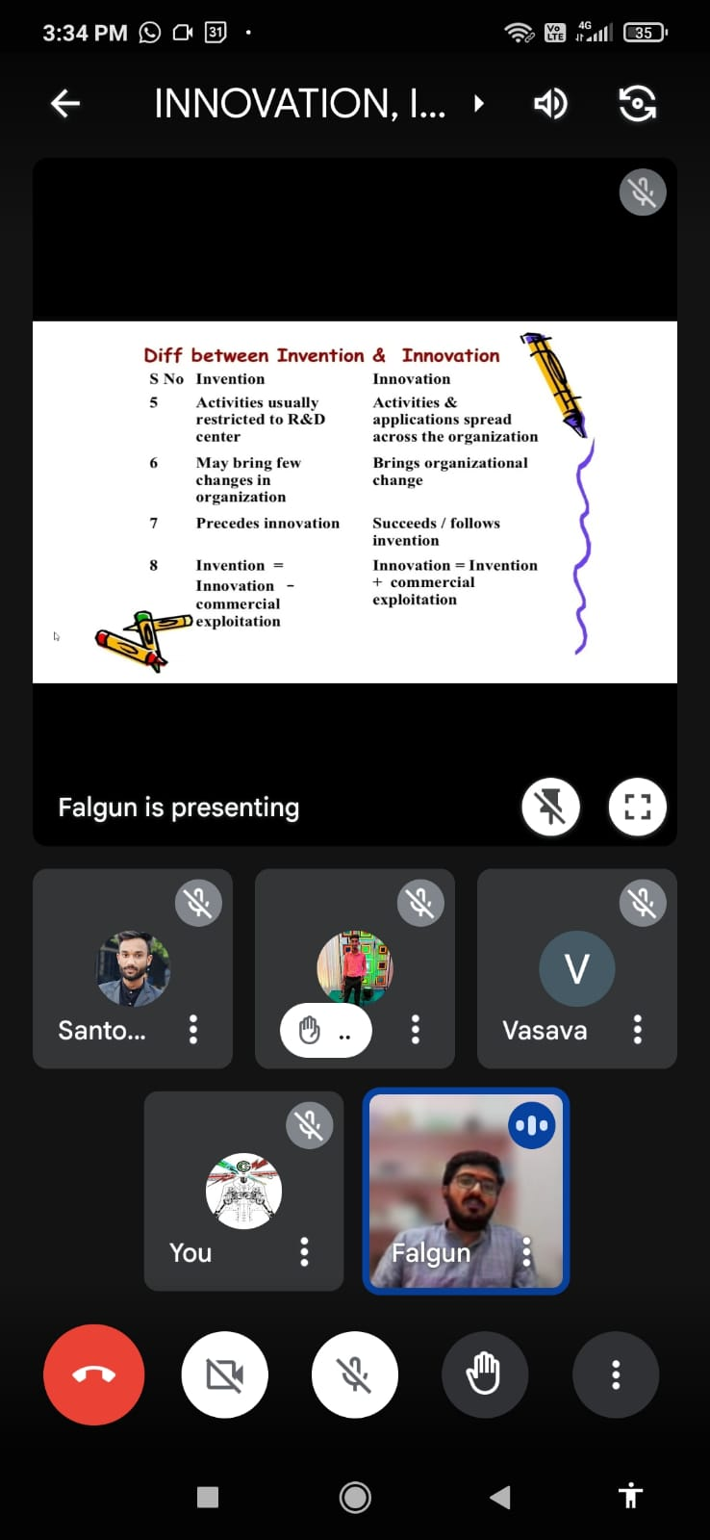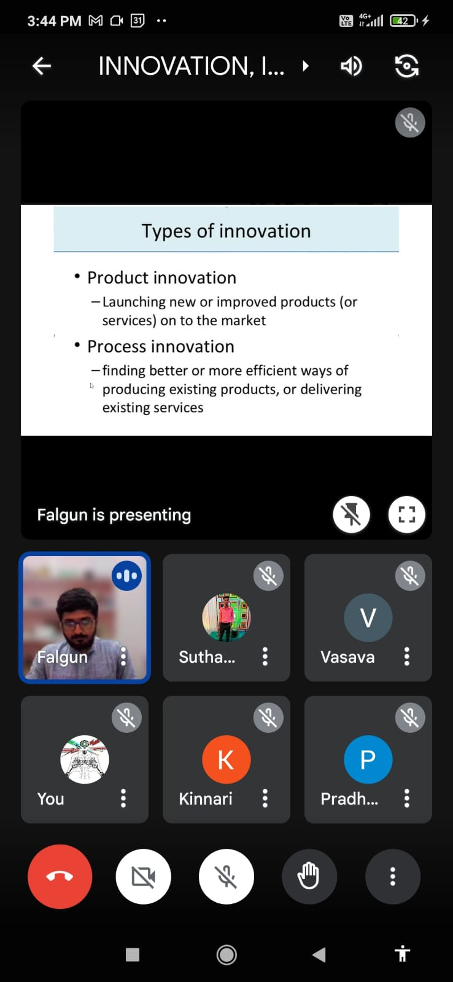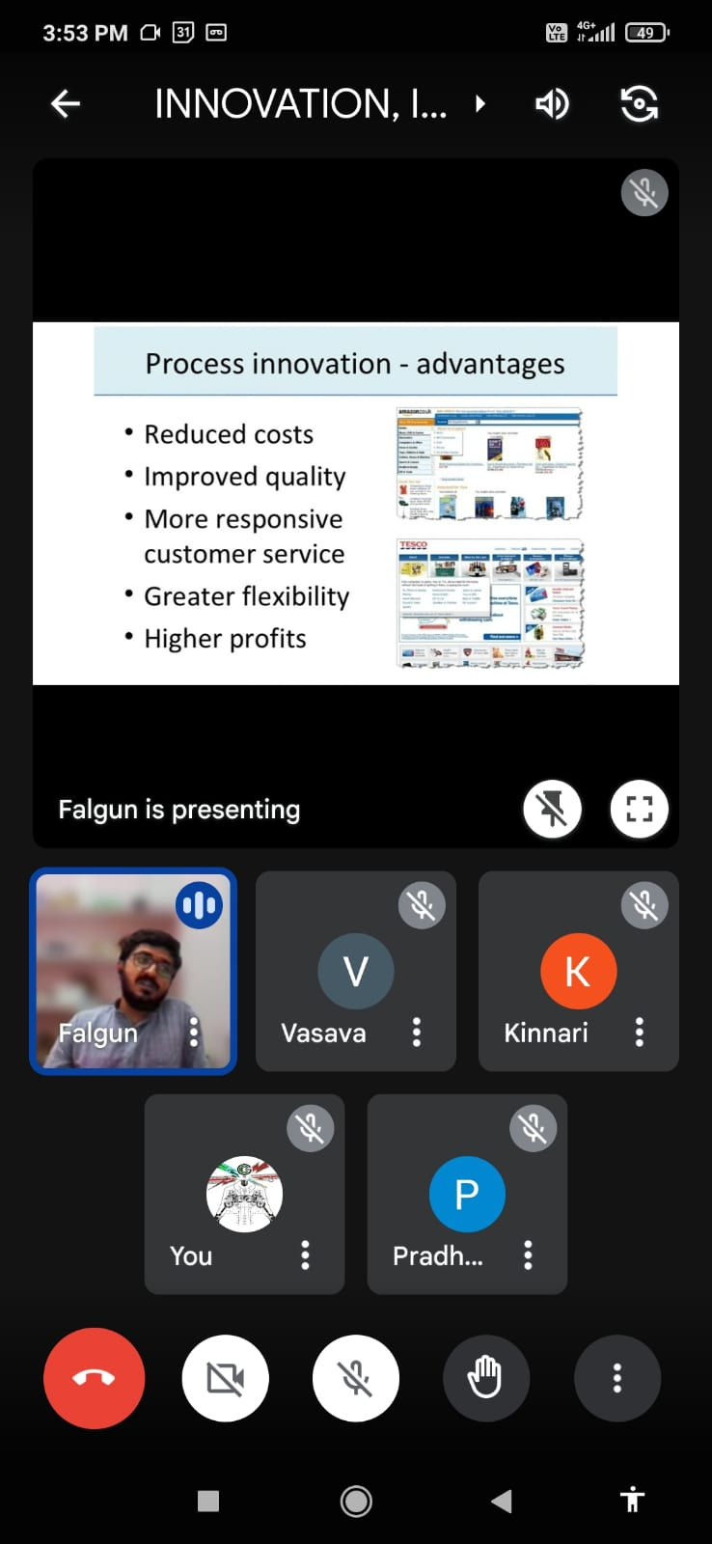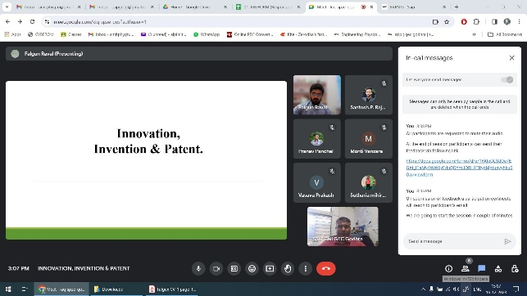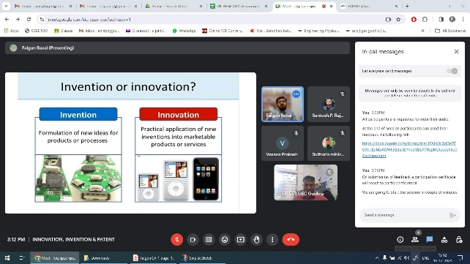

An event of “INNOVATION, INVENTION & PATENT” was organized by SSIP cell, Government Engineering College Godhra on 16th December, 2023.
The program was inaugurated at 03:00 pm via online platform. A total of 10 students and faculty members of all academic branches have participated in the program.
Dr. A. J. Patel, SSIP coordinator & Asst. Prof. PHYSICS introduced the expert of the program Mr Falgun Raval, Ph. D. Scholar (PMRF), Department of Energy and Environment, NIT Tiruchirappalli.
After that the expert gave a presentation explaining various types of innovations and inventions. He also explained in detail about the patent.
At the end Prof. Prakash N. Vasava, Convener of the program & Asst. Prof. Mechanical Engg., GEC Godhra gave a vote of thanks to expert, SSIP team and participants.
The program was concluded with NATIONAL ANTHEM.

