VIKSITBHARAT @ 2047 UTSAV
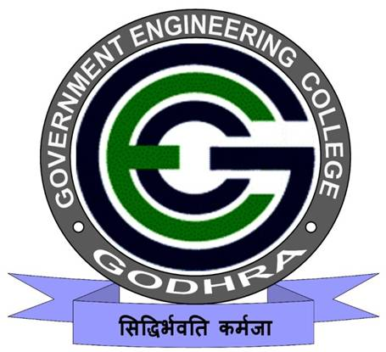
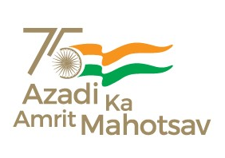
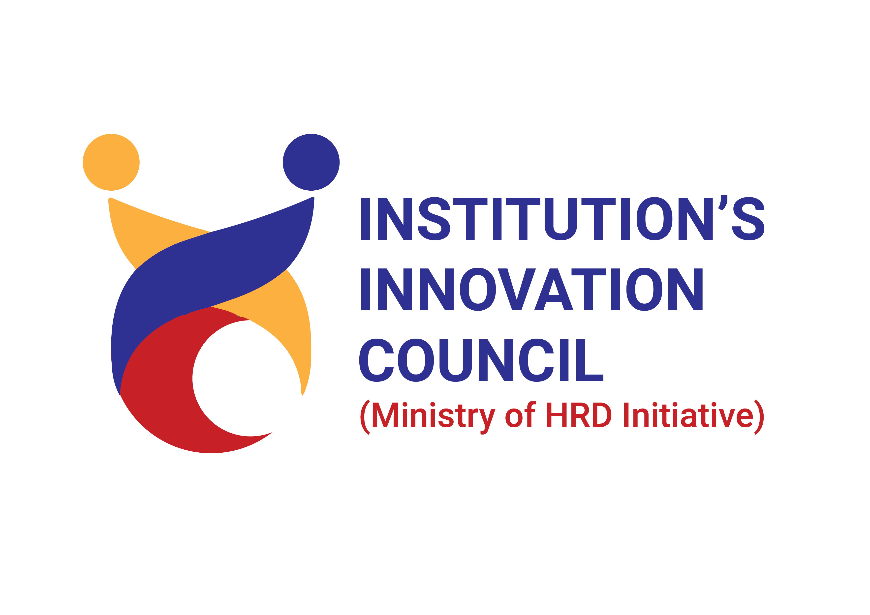
11/12/2023
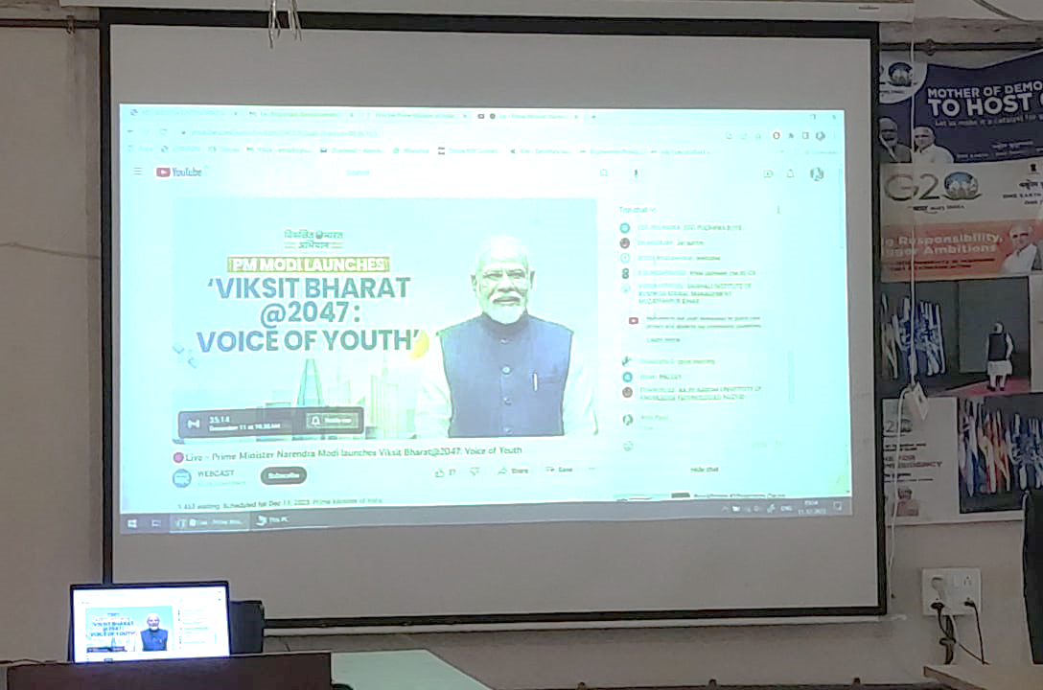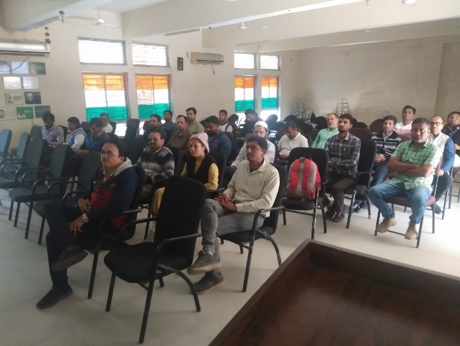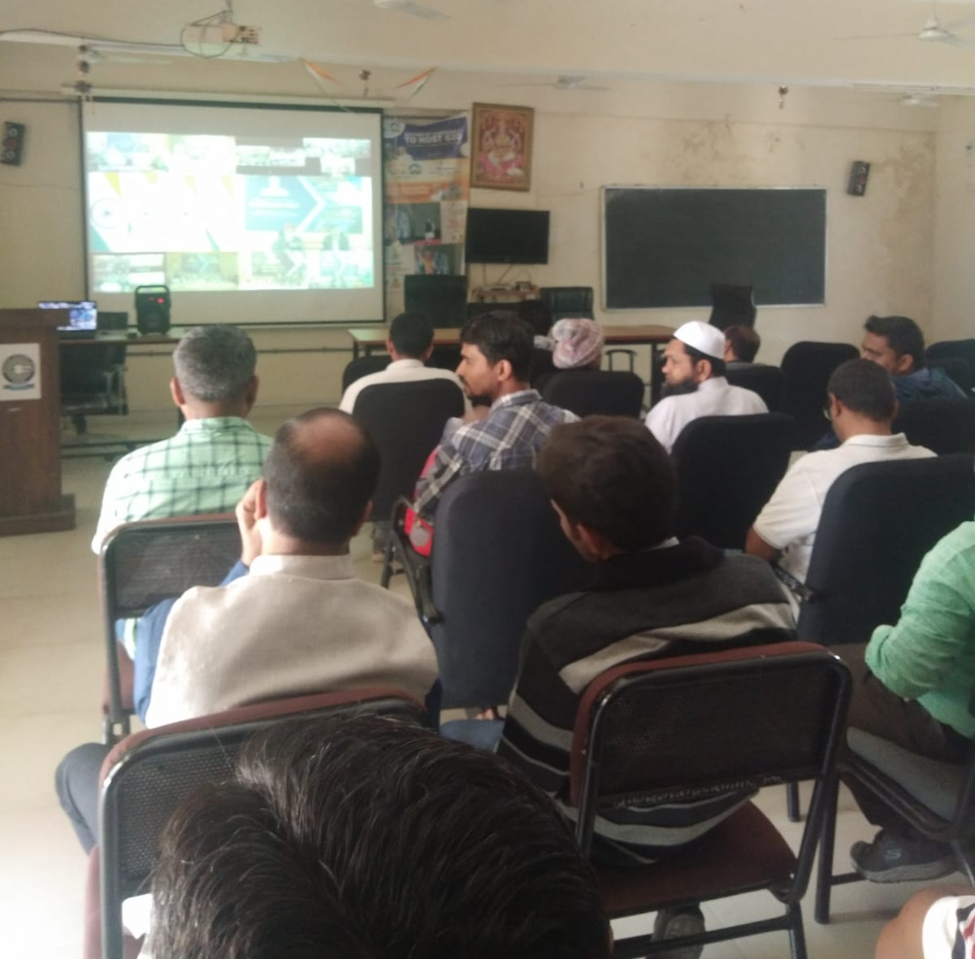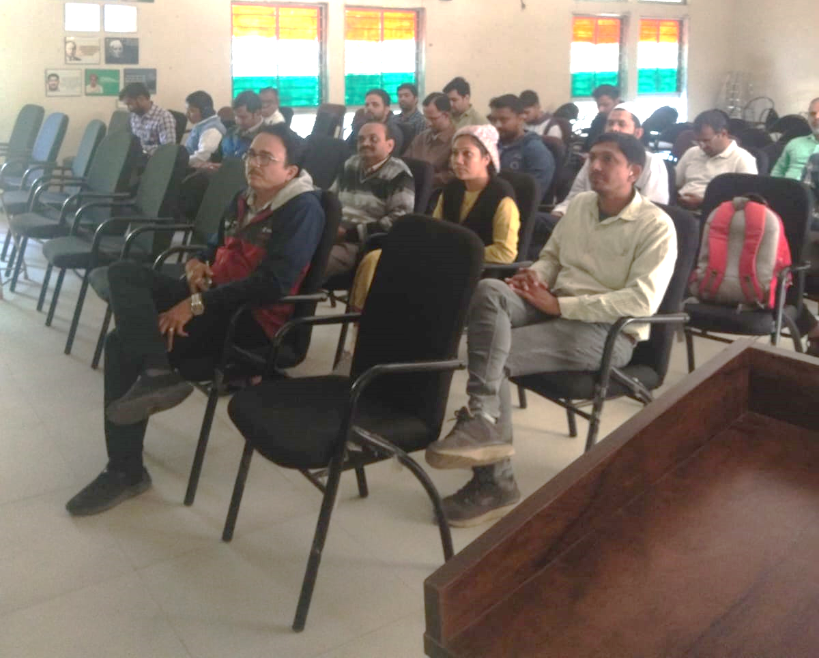

An event of “VIKSITBHARAT @ 2047 UTSAV” was organized by SSIP cell, Government Engineering College Godhra on 11th December, 2023.
The program was inaugurated at 10:00 am at Seminar Hall, Admin Building, GEC-Godhra. A total of 44 students and faculty members of all academic branches have participated in the program.
Program started with SARASWATI VANDANA which was led by female students of GEC Godhra.
Dr. A. J. Patel, SSIP coordinator & Asst. Prof. PHYSICS. Gave an introduction to the importance of the event. After that the broadcast of the “VIKSITBHARAT @ 2047 UTSAV” was seen by all attendees on the projector screen.
At the end Prof. Kinnari P. Shah, Convener of the program & Asst. Prof. Civil Engg., GEC Godhra gave a vote of thanks to SSIP team and participants.
The program was concluded with NATIONAL ANTHEM.
Objective: | To aware and motivate students towards goals of Viksit Bharat movement.
Benefit in terms of learning/Skill/Knowledge  obtained: | Students will receive the motivation to contribute their efforts for strengthening the Nation.
No. of student participants | 30
No. of faculty participants | 14

