STARTUP CONCLAVE



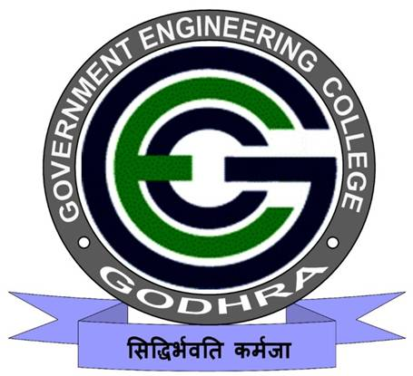

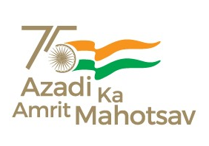

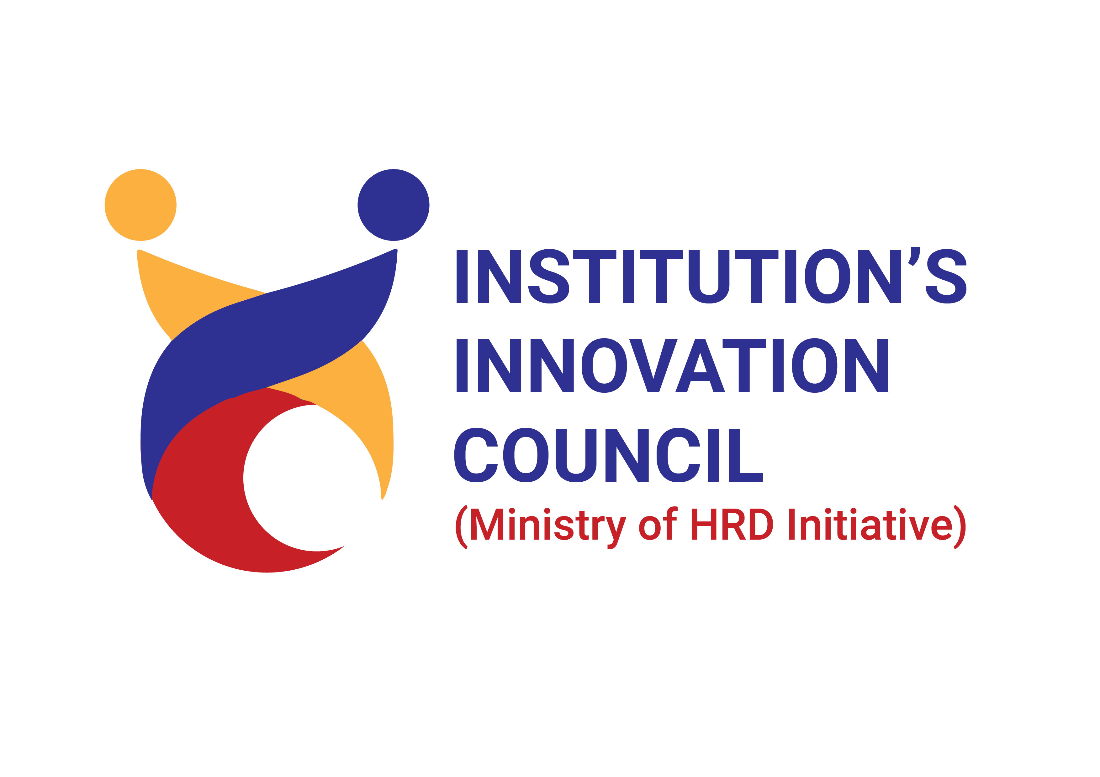

07/12/2023

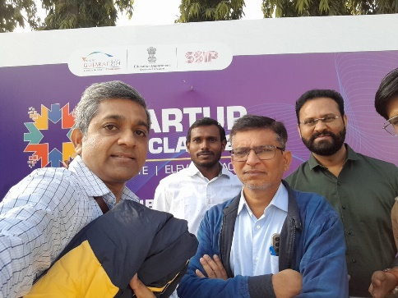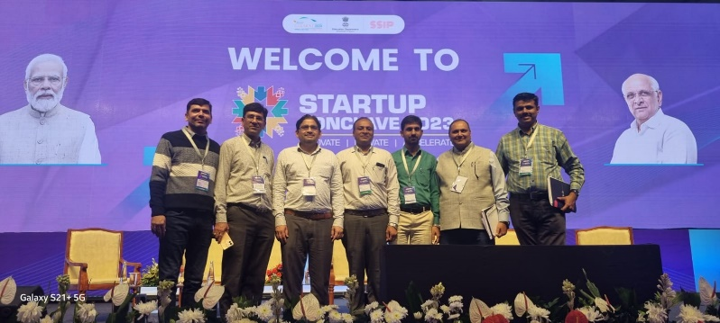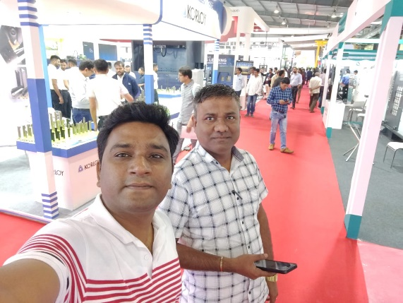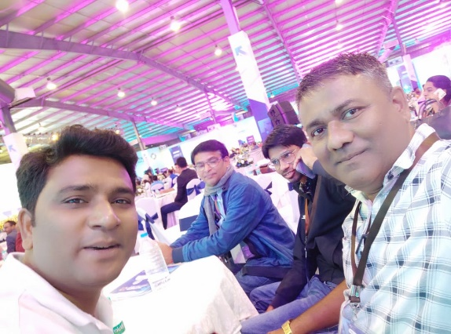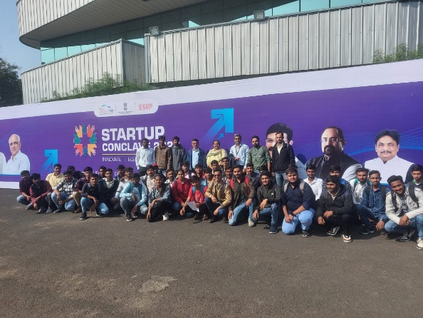

An event of **“STARTUP CONCLAVE”** was organized by Government of Gujarat on **07th December, 2023** at Gandhinagar.

Several Startups and Industries were provided a platform via this event to showcase their progress, products and pathways.

A total of 35 students and 15 faculty members of all academic branches have been sent to visit the program.