INTRODUCTION TO 3D PRINTING
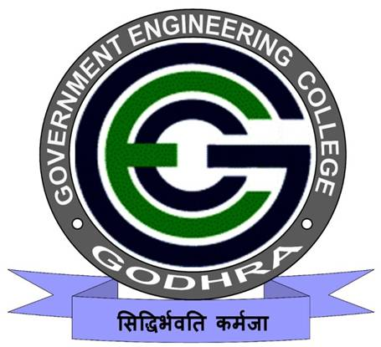
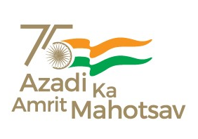
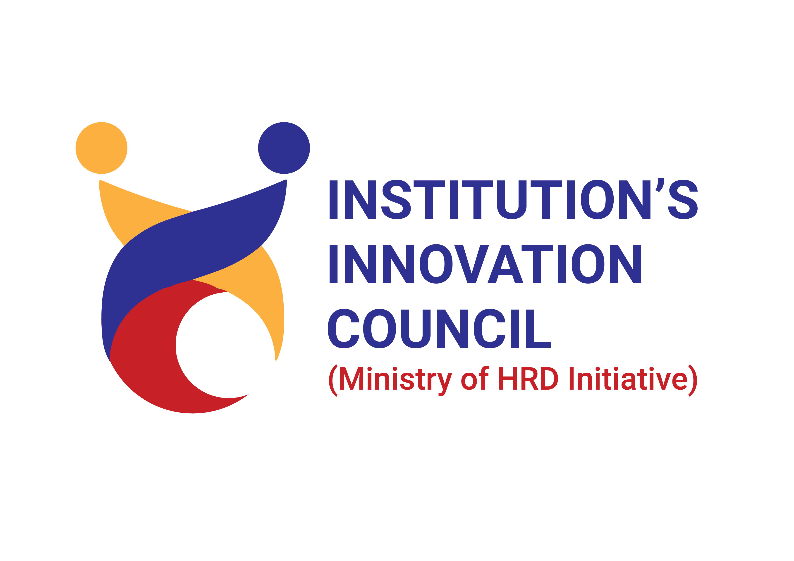
25/10/2023
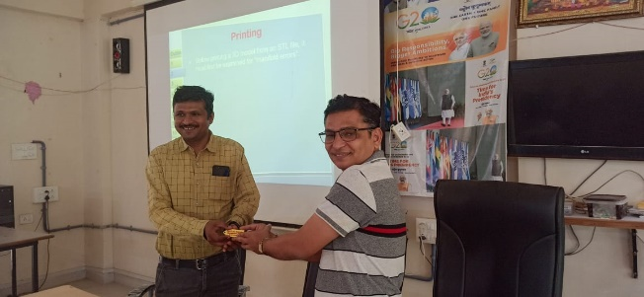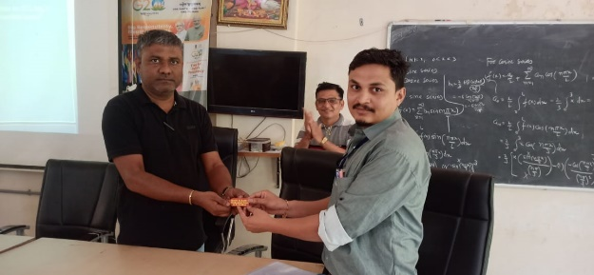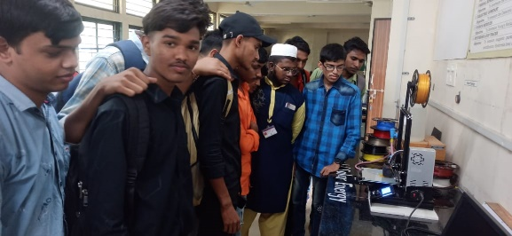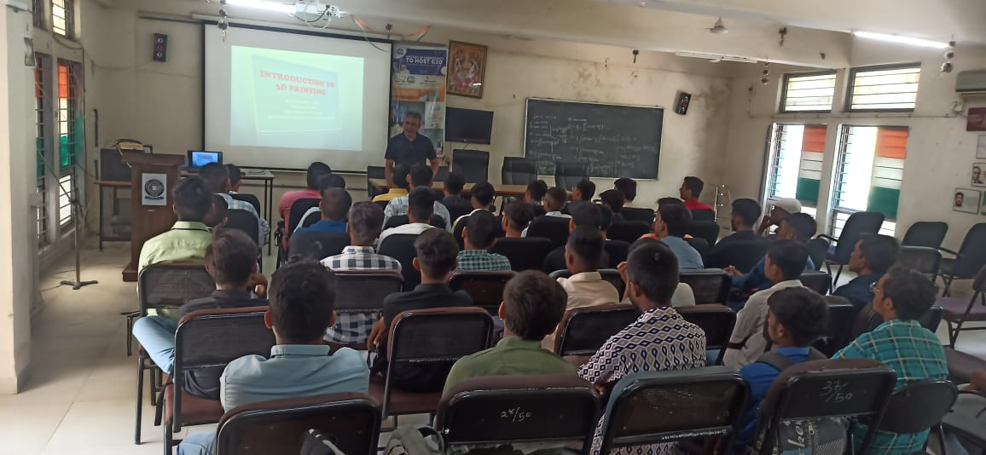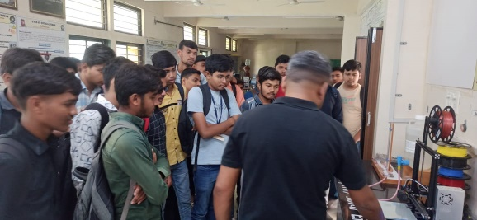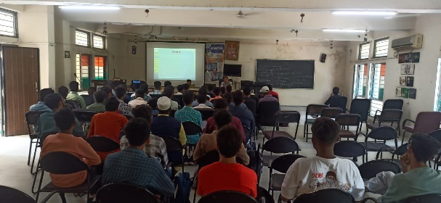

A workshop on “Introduction to 3D printing” was organized by SSIP cell, Government Engineering College Godhra on 25th Oct, 2023.
The program was inaugurated at 11:30 pm at Seminar Hall, Admin Building, GEC-Godhra. A total of 78 students from Government Polytechnic, Godhra have participated in the program.
Program started with SARASWATI VANDANA which was led by female students of GEC Godhra.
Dr. A. J. Patel, SSIP coordinator & Asst. Prof. PHYSICS presented a power point presentation on the printing technologies and step by step procedure from designing to 3D printing.
After that a practical demonstration of designing an object ant its 3D printing was made at the PHYSICS Laboratory, General Department.
At the end Prof. Kinnari P. Shah, Convener of the program & Asst. Prof. Civil Engg., GEC Godhra gave a vote of thanks to Experts, SSIP team and participants.
The program was concluded with NATIONAL ANTHEM.

