A REPORT
ON

Expert Talk
On
“Correlations of Values, Ethics, Innovations and Industry”

In Collaboration With
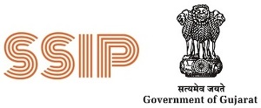
AARAMBH Cell – Student Startup and Innovation Cell

CONDUCTED BY
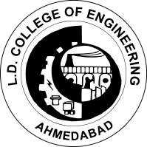
MECHANICAL ENGINEERING DEPARTMENT
L.D COLLEGE OF ENGINEERING, AHMEDABAD

25 July 2023

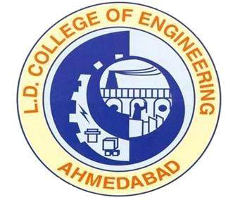
L. D. College of Engineering
Mechanical Engineering Department
Expert Talk

Name of expert: Mr. Parth Gajjar, Associate Manager, Intech Systems Pvt. Ltd.
Ahmedabad.
Objectives of the event:
Students will be able,
- To broaden the horizon related to Mechanical Engineers role in Industry.
- Importance of the values and ethics in corporate system
- To analyze importance of engineering principles, ethics, and Innovations from the Industry perspective
Benefit in terms of learning/ skill/ knowledge obtained:
Newly first year admitted students of Mechanical as well as Robotics and Automation engineering branch interaction with the expert was to envision the importance of basic engineering principles, skills enhancement from industrial viewpoint, self valuation and development, and innovations in the Industry. How to involve themselves in activities based on skill, knowledge, ethics and engineering was the gain by students.
Students thoroughly interacted with the expert and availed benefits in terms of overall objective set up for future endeavors. The session was ended with question answer session along with instant gesture of vote of thanks from the students group that showcase their interest, courage, and self confidence building.

1 | Name of session/ seminar: | Expert Talk on “Correlations of Values, Ethics, Innovations and Industry”
2  3  4 | Date :  Time:  Venue of the Session/Program: | 25/07/2023  11:00 am to 13:00 pm  Room No. 603, Mechanical Engineering Department, LDCE
5 | No. of participants: | 64 Students
6 | Name of Coordinator: | Prof. M K Vyas  Assistant Professor  Mechanical Engineering Department
7 | Photographs of session: | Attached

