GOVERNMENT ENGINEERING COLLEGE-VALSAD
MECHANICAL DEPARTMENT
Date: 19-12-2022
SSIP DEPARTMENTAL SCRUTINY
The departmental scrutiny for departmental SSIP proposals held on date 19-12-2022. Total 15 teams (48 number of students) represented their SSIP proposal in front of the scrutiny members in CAD lab of mechanical engineering department. Out of 15 teams, 10 teams selected for college level scrutiny.

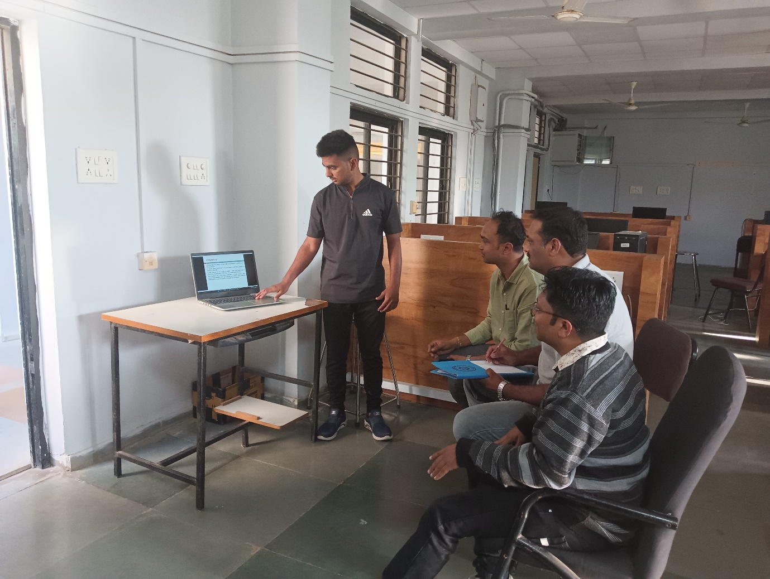

Dept. SSIP Coordinator H.O.D
( Prof.S.K.Patel) Mechanical Engg.Dept

